### Unity Catalog User Provisioning

we will learn how to bring your corporate users or your domain users into Databricks Unity Catalog so that we can create user groups and manage privileges for those user groups or individual users. So let's try doing that. in this lecture I'll give you a demo on how to bring your users. So provisioning your company users into Unity catalog is done through the SIM connection. So what is SIM connection. Let's try to Google it and see what is sim. So SIM is the system for cross-domain identity management. So it's a protocol, to bring users from one domain to another domain.

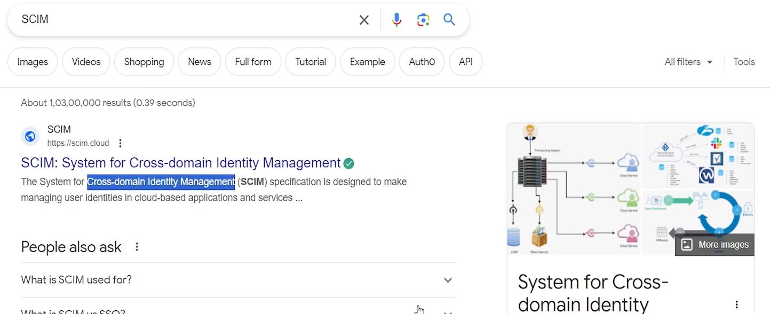

That's how most of the, cross domain user management works. So Databricks also follows the same, protocol or same type of connection. So we will be using SIM connector to bring users from my domain to Databricks workspace.

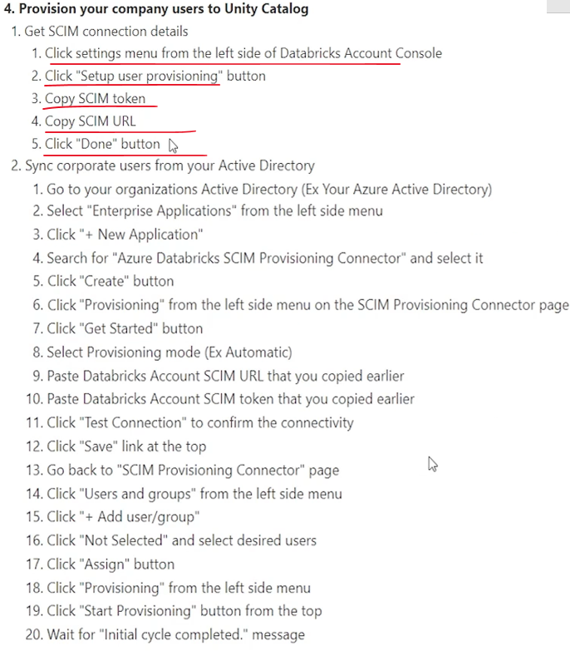

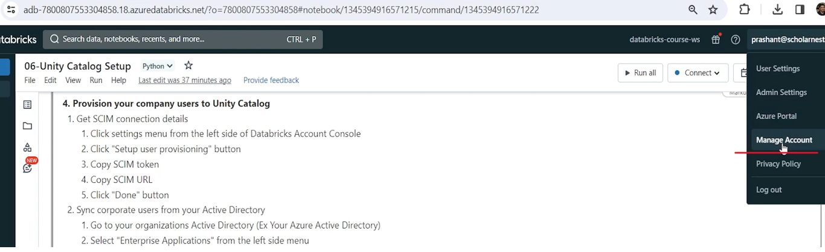

Let's go to the. Databricks Account Console. I'll go to Databricks Account Console and in click settings menu from the left side of Databricks Account Console. So we'll come to the settings menu. And in the user provisioning tab you will see setup user provisioning.

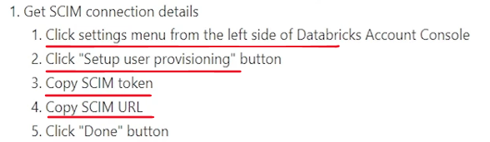

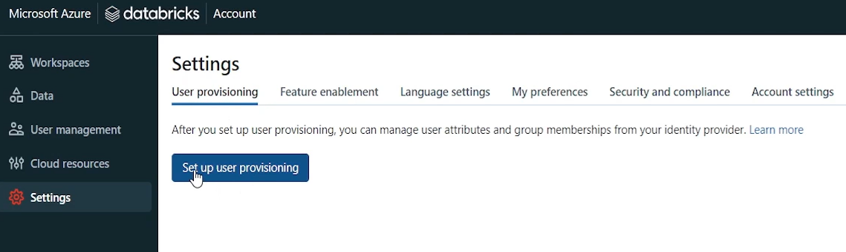

So hit that button and it will show you a SIM token and account sim URL. So step is setup user provisioning. Copy the SIM token and sim URL. And that's all from here. So let me copy it and keep it somewhere in my notepad. because this is a token, you might not see it again. And this is your, sim URL. So we copy the sim URL and keep it in a notebook, and then finally hit the done button.

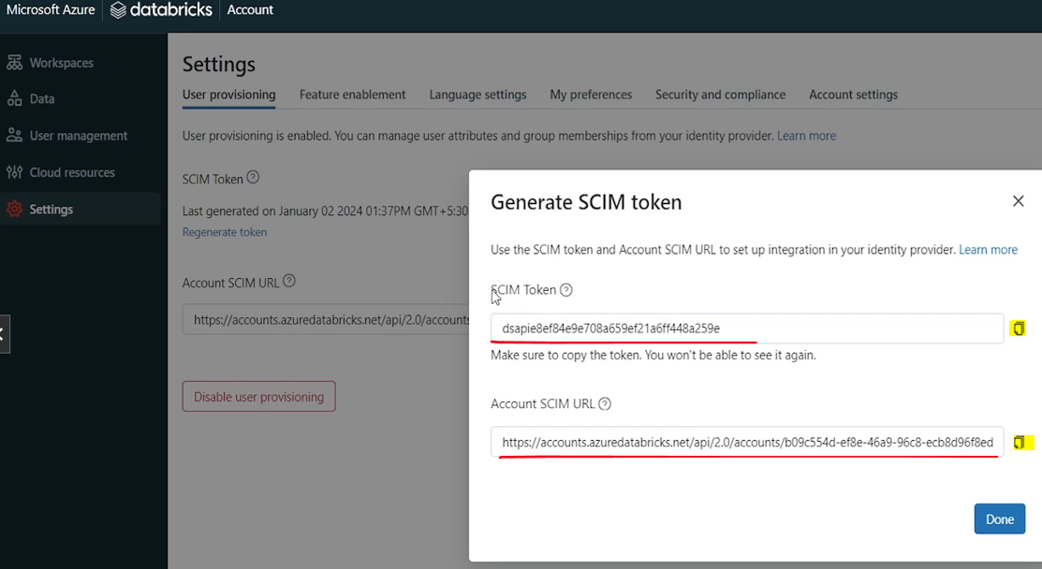

So that's all we are done from here. Basically we created a token and we created a URL for user provisioning in the Unity catalog, Databricks Unity Catalog. And then we will take this token and URL, go back into our Active Directory, our Corporate Active Directory, and configure, our corporate Active Directory to sync users from our corporate Active Directory to the unity catalog. Our Active Directory will push the users to the unity catalog, or user details to the Unity catalog. I don't have a corporate Active Directory, so I cannot show you the corporate active Directory, but I have, Azure account.

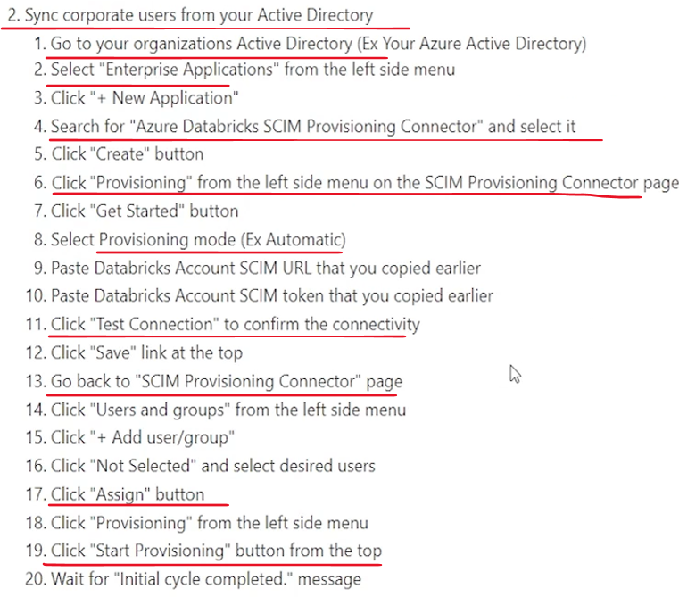

So in Azure account I have Active Directory, come to Microsoft Entra ID, which is Active Directory. Active Directory is now known as Entra ID and will see how things work from here itself. That's good enough for learning the process. So. Let us come and see what is. What are the steps? Go to your organization's Active Directory example, your Azure Active Directory. Select Enterprise Applications from the left side menu. So in the left side menu, in your Active Directory you will see enterprise applications.

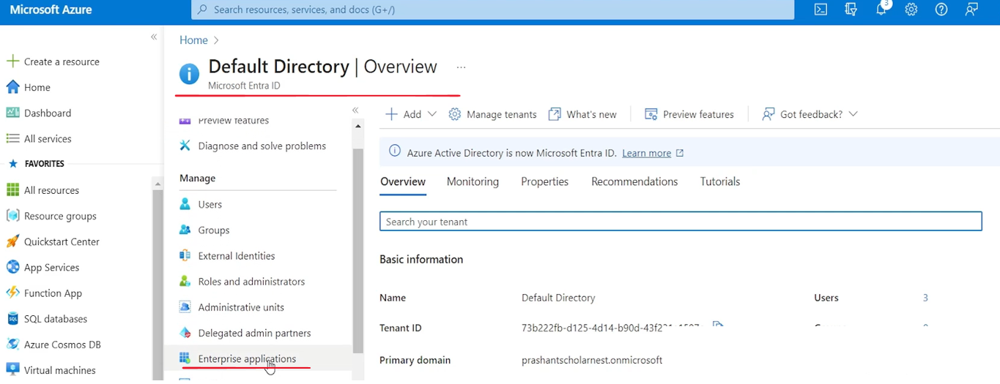

So here I am on the enterprise applications page. what is next? create new application and then search for Azure Databricks HCM provisioning connector. So we will. Search for the new application and Azure Databricks SIM Provisioning connector.

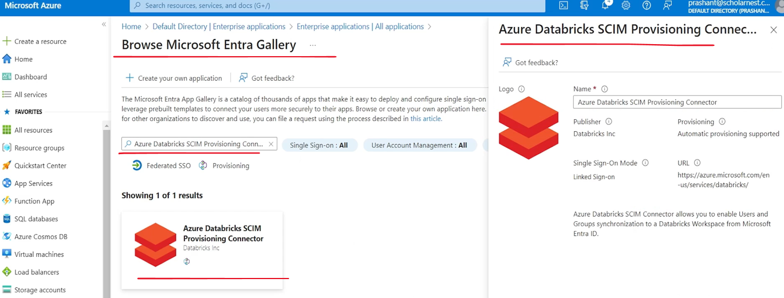

So just choose this connector and let's see what is the. Click the create button.

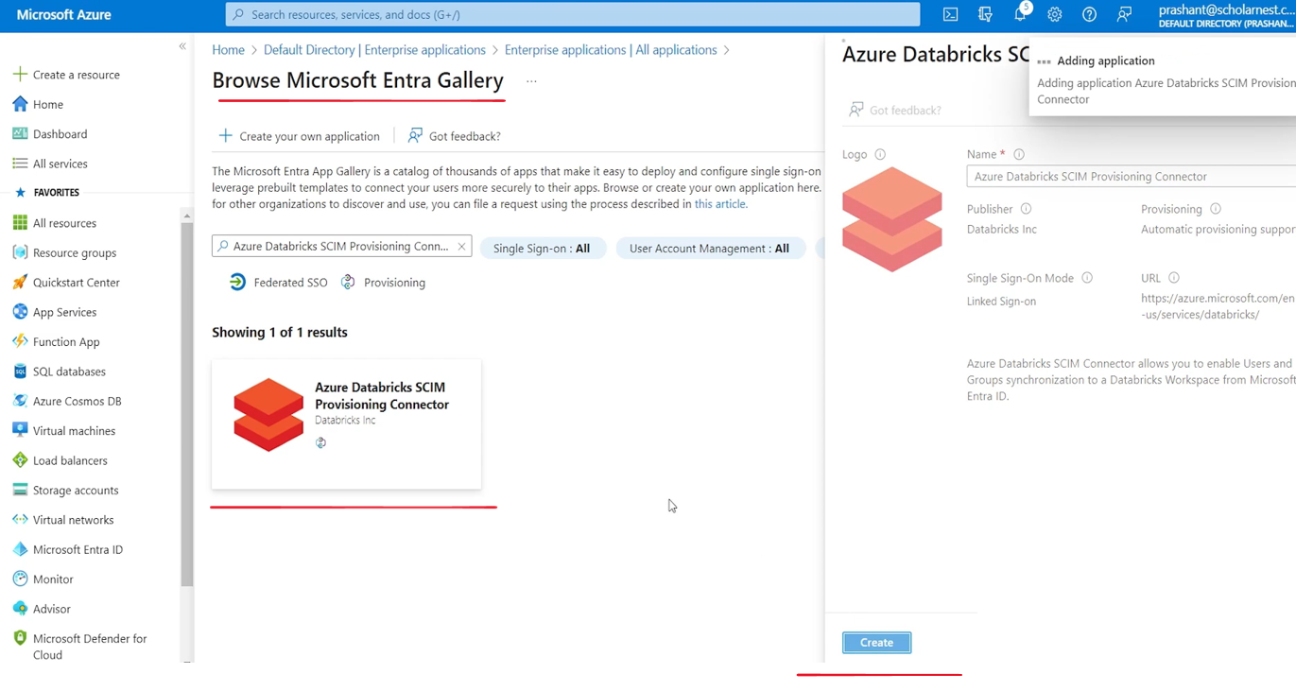

So let's click the create button here. And let's wait for connector to be installed in my Active Directory or configured for my Active Directory. So Databricks and Azure they came up with this connector. So you can provision users between Active Directory and Databricks Unity Catalog. So my connector is, created now.

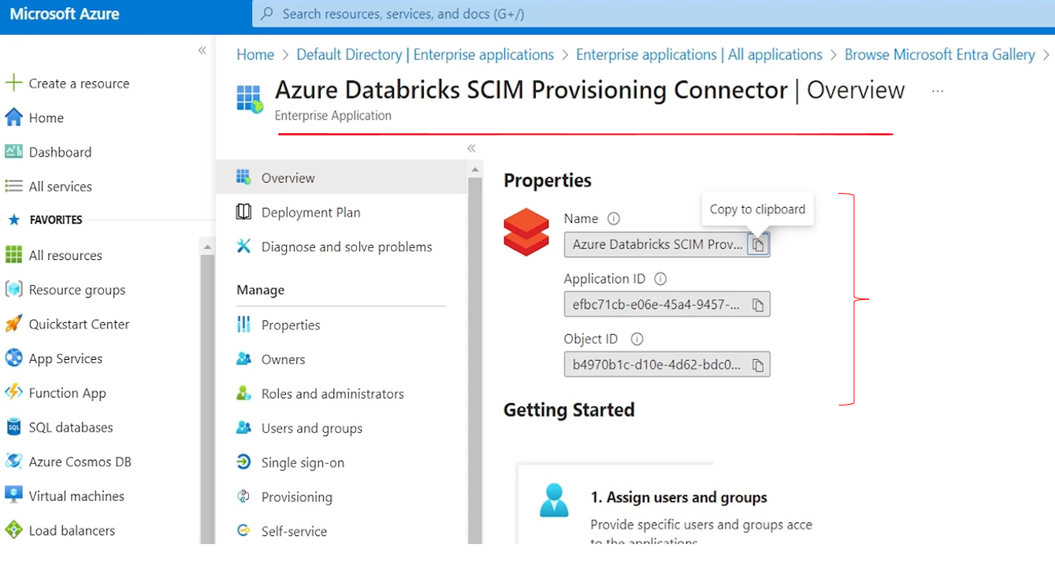

What is next? Click provisioning from the left side menu on the SIM Provisioning connector page and click Get Started button. So on the left side menu you should see somewhere provisioning. For that connector. And then click the Get Started button and provisioning mode. We have two modes manual and automatic. Let's choose automatic and it should automatically sync my users. And then we have to provide tenant URL and secret token.

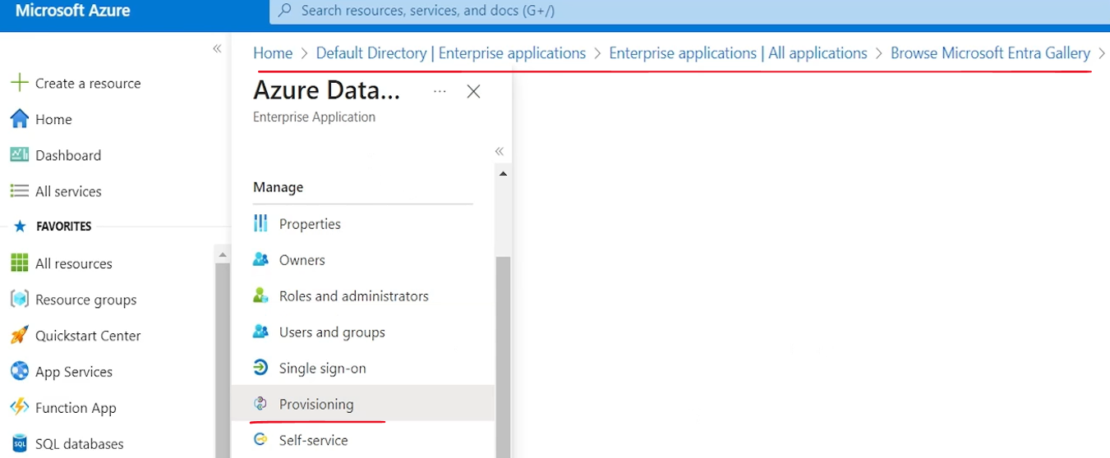

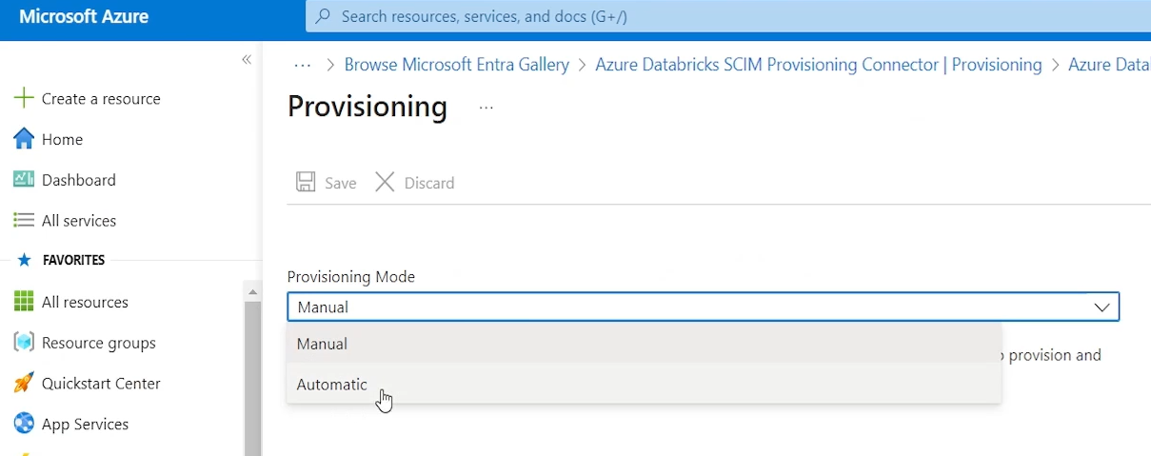

So these are the things that we copied from our account console Databricks account console. So let me paste those things here.

So this is the irl sim connector URL that I copied from here. Sorry. From here this is the same URL token is not shown. You can if you lost your token you can regenerate your token.

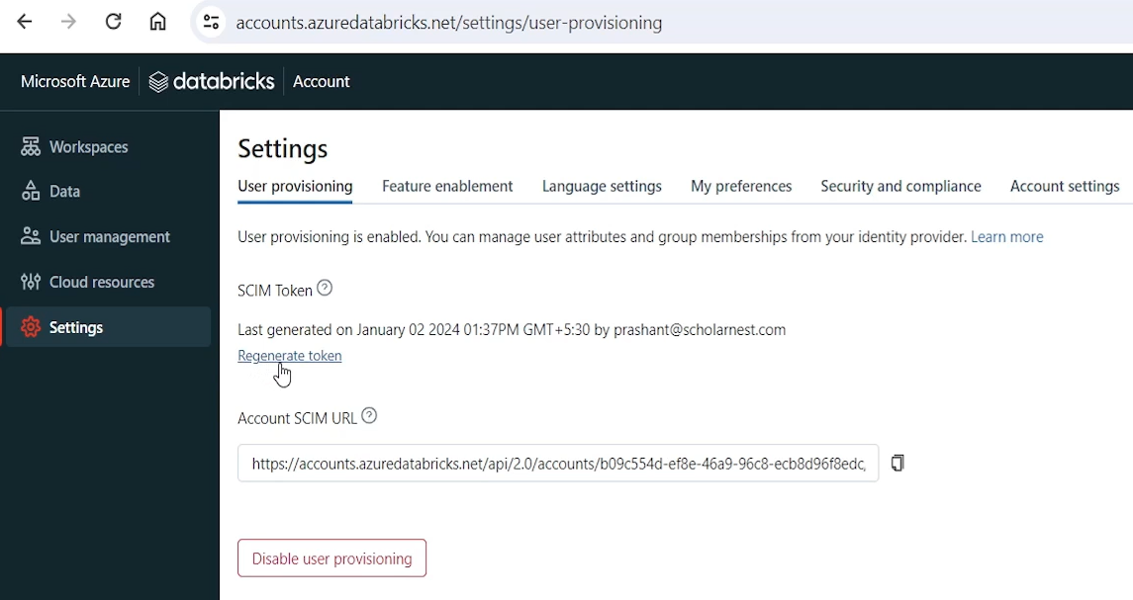

But I already kept it. So I'll paste the token here. Paste the token here. if everything is working, then test connection should pass. So let's test the connection. So it is testing whether Active Directory is able to connect to the Databricks platform. So testing connection to Azure Databricks SIM provisioning connector is successful. So that's successful.

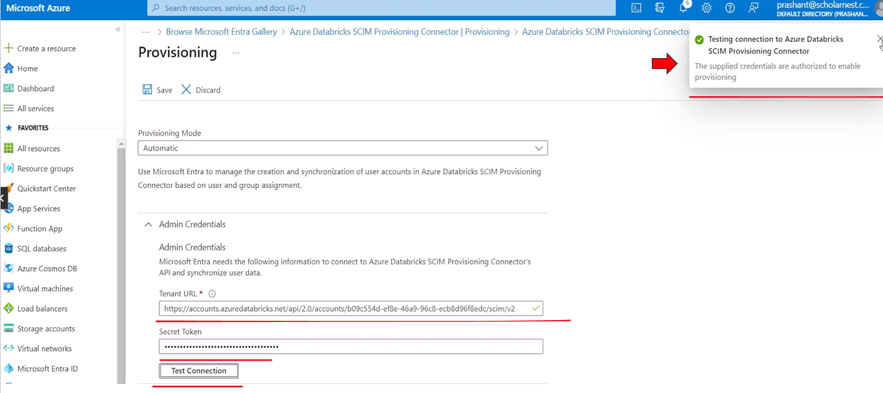

Next, go to SIM provisioning connector page once again and choose Users and groups. So connector is set up.

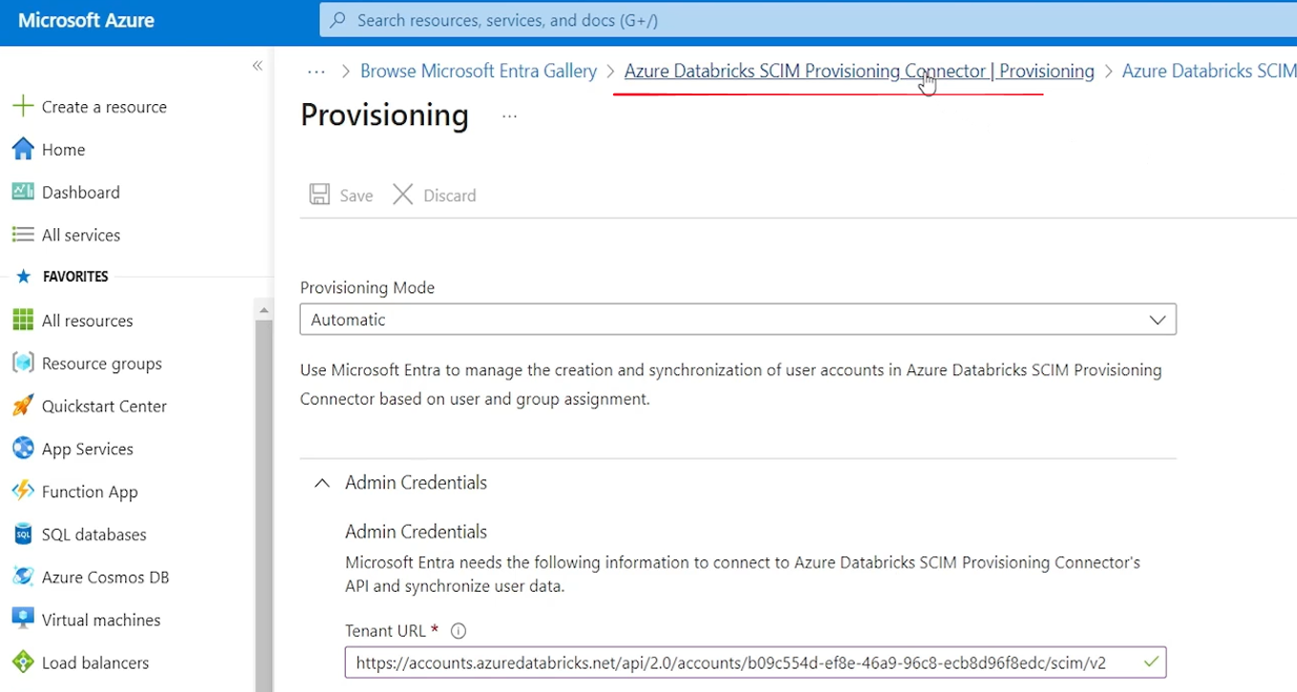

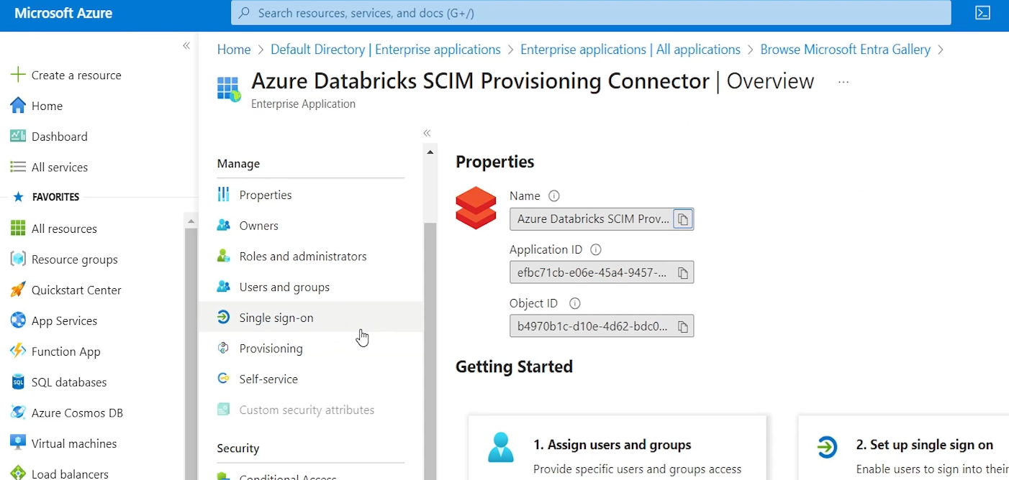

We have set up the connection details and all that. Now you can come back to your connector page from here. Right. We are back on the Azure Databricks SIM Provisioning Connector page. And you have users and groups here.

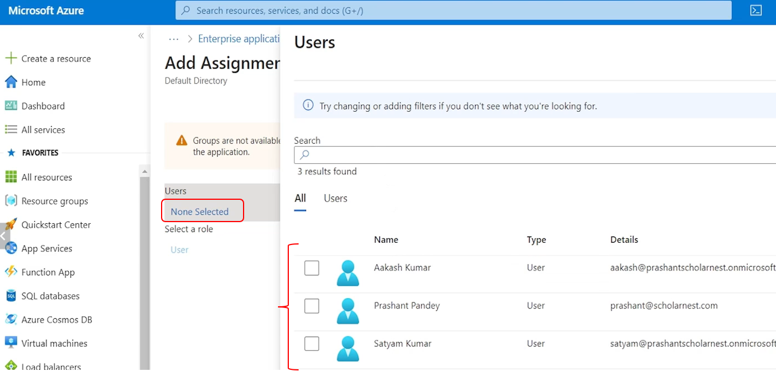

Click Add User Group and click Not Selected and select desired users. So we set up the connector. But. Which users do we want to? Share or push to unity catalog. That's what we are going to do from here. So add users, none selected. And then you will see all your users here. Right. So I have three users in my, Active Directory for your company. You might have hundreds of users. you can also choose user groups instead of individual users and push the entire group. But for doing that you need, advanced level of Active Directory subscription. I have a basic Active Directory subscription, so I cannot show you that. But idea is that instead of pushing single users or individual users, you can have a user group which are, user group created for a particular project and push the entire user group at once. So for me, let's try pushing some users from here. I am already there in the unity catalog because I'm the owner of that Databricks instance. Other than that, I have two users I don't want to push all. So let's select only this user and click the select button.

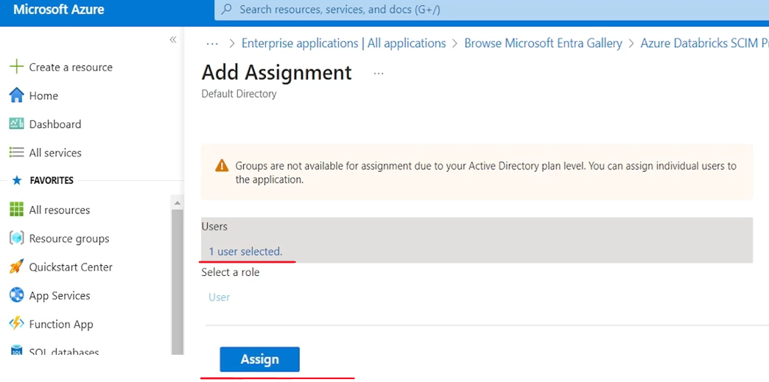

So one user selected and let's hit the assign button. And this user is now. Member of this provisioning connector. So this user should be pushed to the unity catalog. And let's say assign button click provisioning from the left side menu and click Start Provisioning.

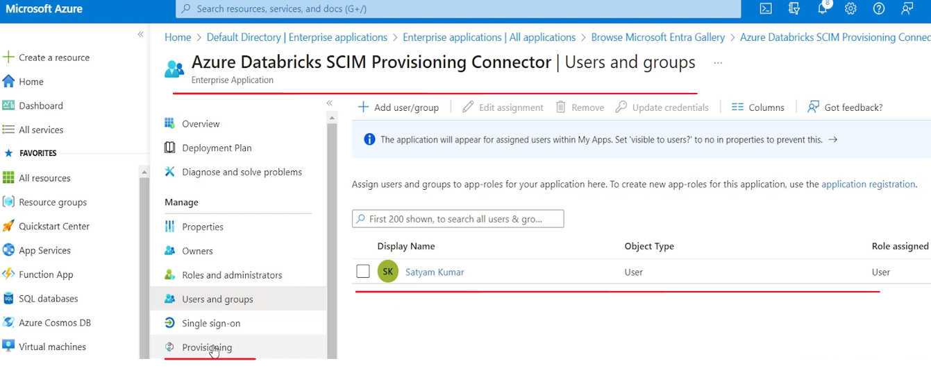

So again come back to the left side menu provisioning. We defined the users what all users we want to provision and hit the start provisioning button. And it's running the initial cycle. It's still not run. Maybe in few minutes it should finish the initial cycle.

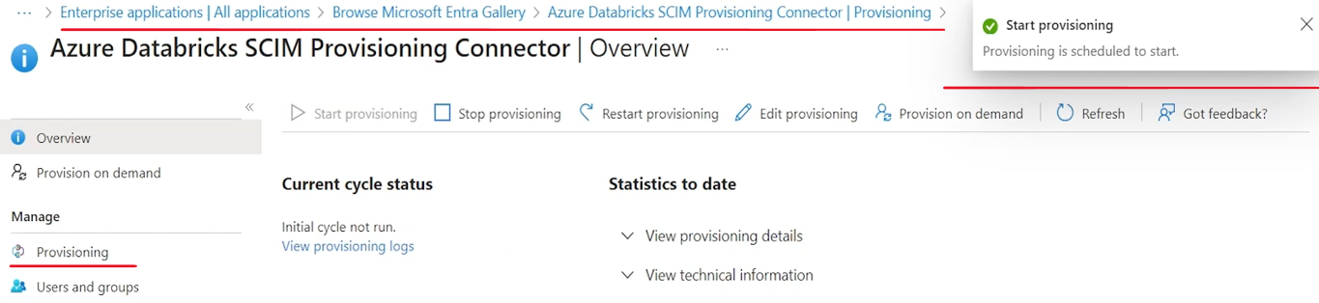

If it's still it doesn't finish, maybe you can restart provisioning or stop and then again start.

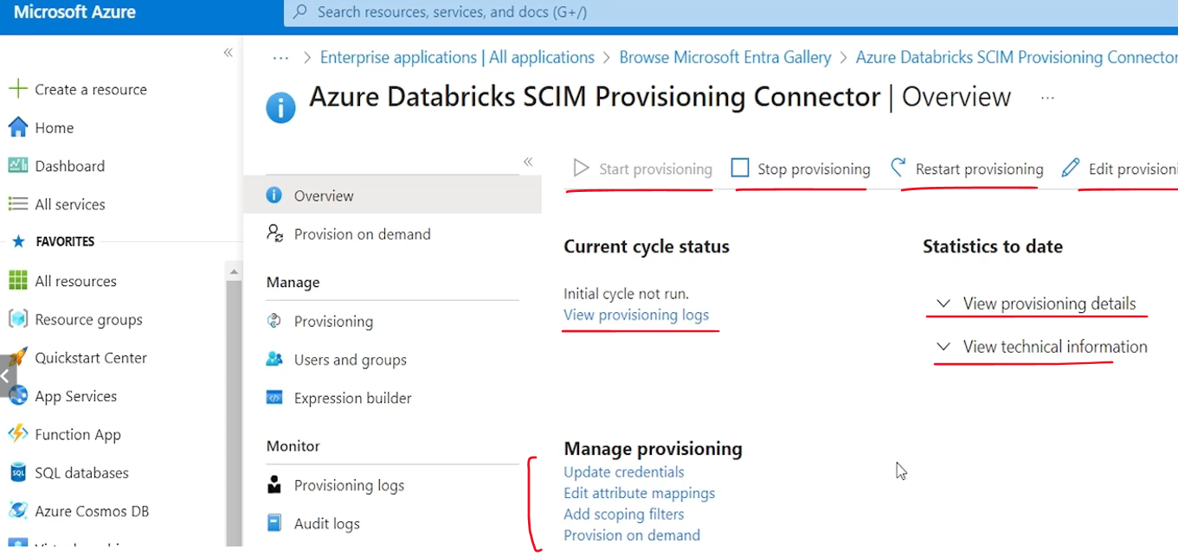

Okay, so I refreshed the page and I can see, initial cycle completed. and we set up automatic provisioning so it will keep on provisioning more users. If you have, tried to provision a user group. So as soon as you add new users in the same group, it will automatically provision them. Or you want to add your, users back here. So if you add one more user in this, list here, only sathyam is shown. If I add one more user in this list, it should automatically provision. So provisioning cycle is complete.

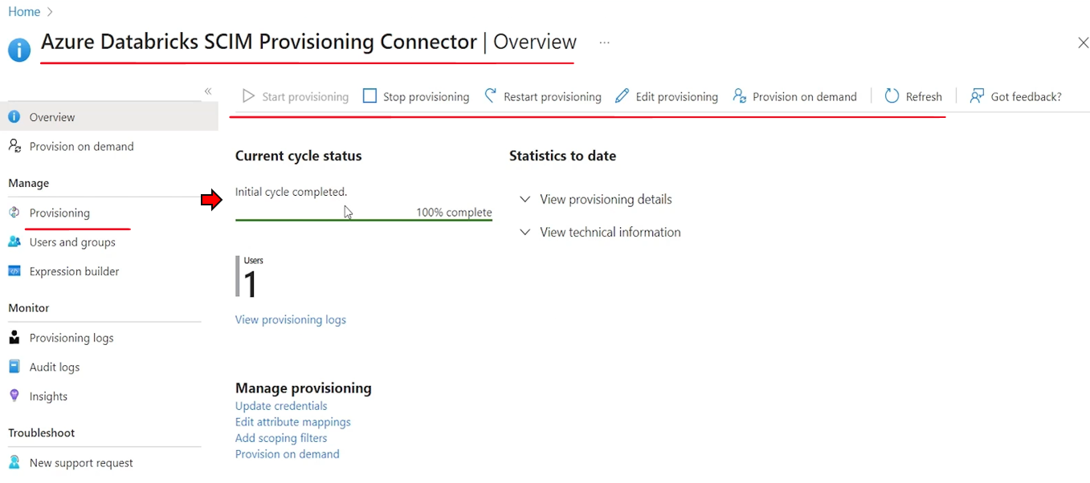

So let's come to the Unity Catalog Account Console and go to User Management. And okay I can see Sathyam is now visible here. Sathyam is now part of the unity catalog. I'm already there since I'm the owner.

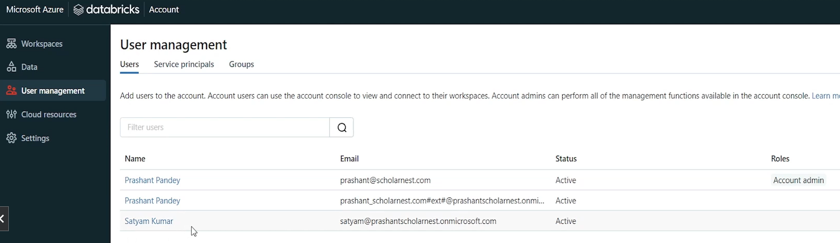

Wait for initial cycle completed message and you are done with the user provisioning. So we are done with the user provisioning. What is next? We can create user groups and once the groups are there, we can start creating objects and then granting privileges to the user groups or individual users.

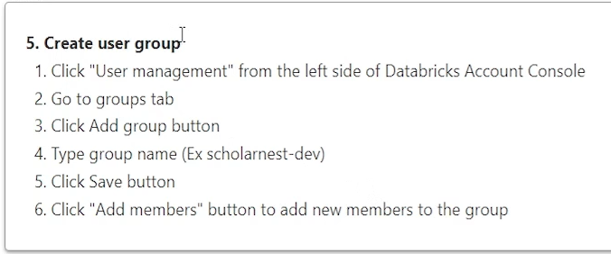

So how to create user groups. Let's come to the account console and you can see groups here. So click User Management from the left side of Databricks Account Console group.

|  |  |
| --- | --- |
|  | Go to groups tab and click add Group button. So there is already one group Pre-created which is default account users. All the members are by default made part of this group, but we can create our own group. So let's create a new group. Let's call it scholar-nest-dev group. And you can create as many as you want. So I created one group.  Now I want to add members to this group. So this group is created add members. let's search for. Set them right. I want to add set them to this and click the add button. Set them is added. I'm not added so let me. Add myself also Prashanth at Scholar Nasscom and add myself also in this group. |

So we created two members in this group and click the save button and add members and you are done. So that's all we have the user group also. Now we are done from the unity catalog, side. The rest is you start creating database or schema catalog tables volumes and then start giving privileges.

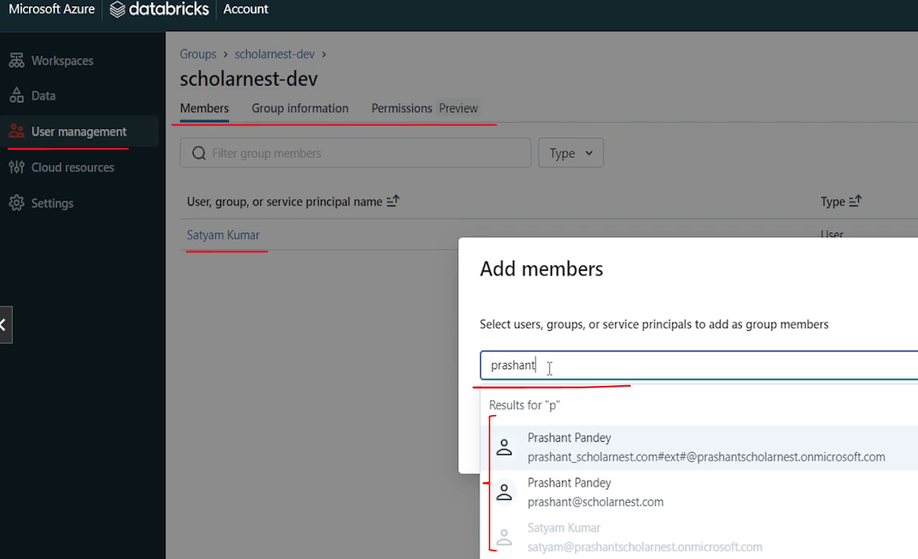

### Working with Securable Objects

We learnt to set up our storage layer and create a Unity Catalog Metastore. And then we enabled our workspace with the Unity Catalog. We connected Unity Catalog with our workspace. So now I am ready to start creating my data objects and use it under the unity catalog. So let's try to see few examples of how we use Unity catalog in our project. So I have already set up one notebook for this demo. So let me go there and start using it. So. I already have a running cluster. It's attached with my notebook. Before I start something, let me run a cleanup script. This cleanup script will simply clean up a few things that I, created or provisioned for earlier lectures or for this current, lecture, as well. So if you are following along, if you are using one of our, notebooks, it is always recommended to run the cleanup before you start doing your own hands on activities. So I am done with the cleanup. Cleanup is executed.

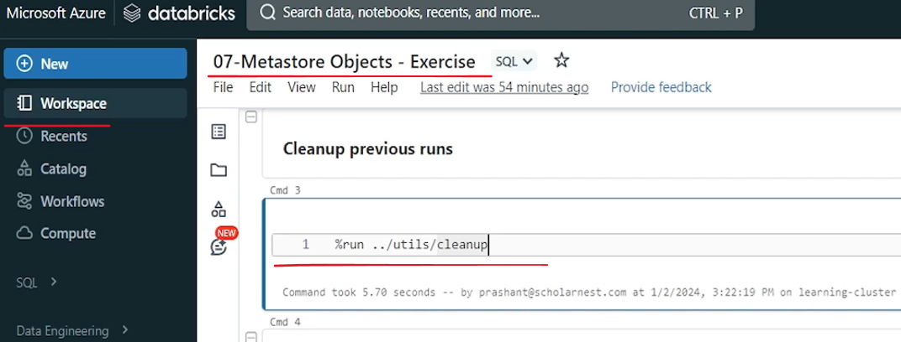

Now let's start understanding how Unity Catalog objects can be created and used. So in the unity catalog, the first level of the object is a catalog. You have to create a catalog, and then inside the catalog you can have. Databases, tables, views, functions, volumes, all other things. And usually we create catalogs for environments or for projects. So let's assume you have a project and you want to create two catalogs for your projects. One we call it dev catalog and the other as QA catalog. So let's create a catalog. So how to create it? Simple. Create Catalogue - for safety you can use - if not exists and give a catalog name. Let's call it dev catalog. Let's create one more. I'll simply copy it and change the catalog name. Let's call it QA catalog. So that's how you can create a catalog.

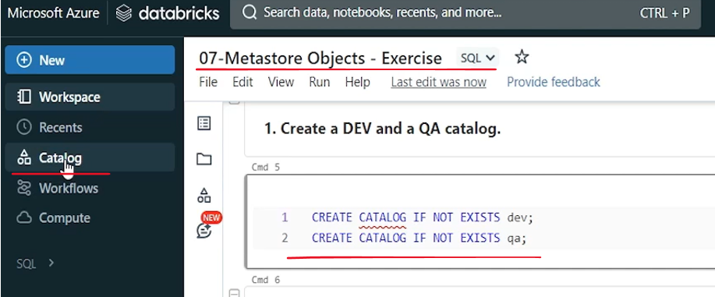

And while we are creating the catalog, let me also introduce you to the Catalog Explorer. So in your workspace you can see this catalog menu. Let me open it in a new browser tab. So here is the Catalog Explorer. This is a UI that allows you to work with the Unity Catalog managed objects. So from here you can see we have three, catalogs already shown here. One is the system catalog, which is owned by system user, it's automatically created for a new unity catalog, setup.

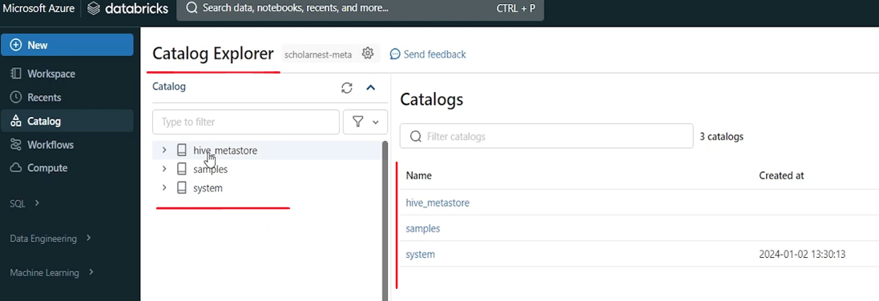

And we have an information schema already created in the system catalog. And inside the information schema you have a lot of metadata tables. So if you want to do some query on the metadata, you can get the details from this information schema in this system catalog.

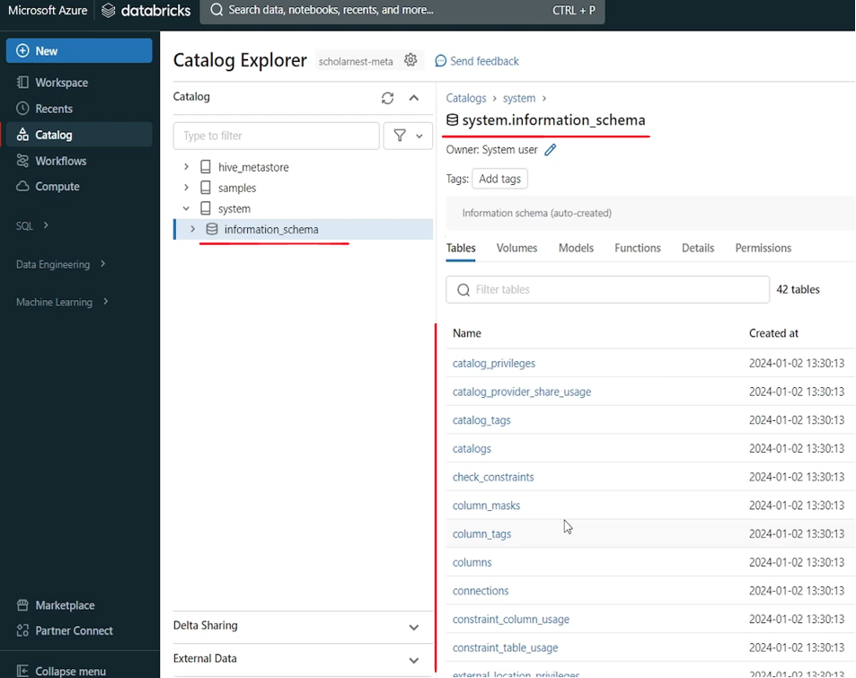

This is a sample catalog which is owned by Databricks Inc. It's automatically created for a new unity catalog setup. you can ignore that.

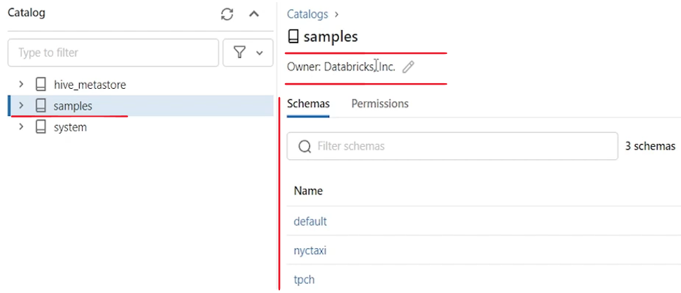

We also have a catalog called hive. Metastore. This is not a unity catalog.

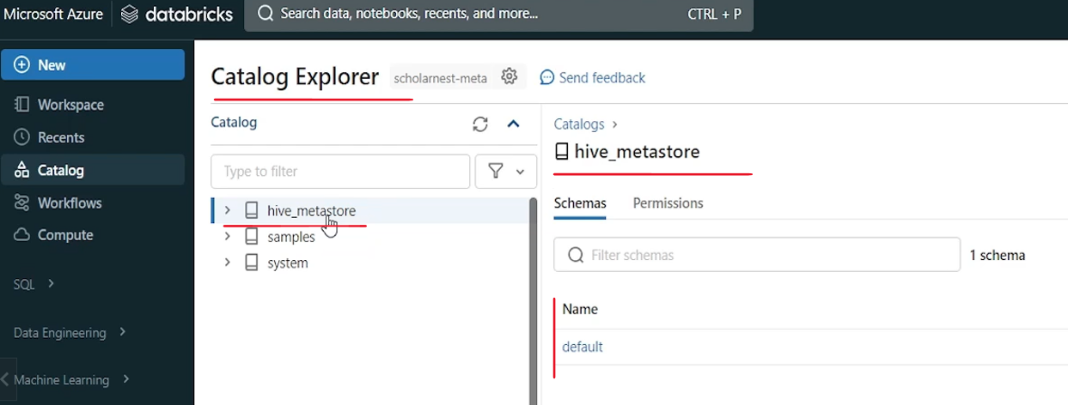

It is workspace local catalog. So if you do not have a unity catalog setup for your workspace, you will only have Hive Catalog. Once you set up the unity catalog, you can create new catalogs using Unity Catalog and have your own catalogs. Otherwise you will have only one local workspace Local Hive Metastore catalog available to you. So in the hive Metastore catalog, whatever objects you create. For example, if you are creating a database which sits into the hive meta store in this current workspace, and that object cannot be shared across multiple workspaces. So hive Metastore is your local workspace local catalog. So what we want to do, we want to create two new catalogs from here. Right. So let me run this code and I can create, two new catalogs. It's done. If you come to the UI, you will maybe refresh this and you will see those catalogs, dev catalog and QA catalog.

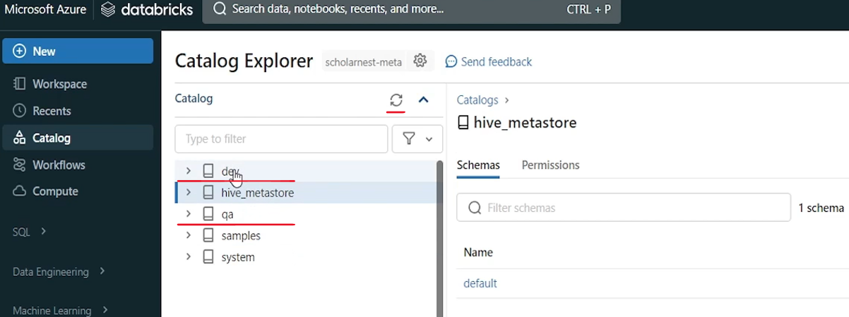

Inside the dev catalog, you will see a default, schema or database and information schema. These two are automatically brought into every new catalog. So default is there ( blank ). Information is schema is the same which we saw in this system. So that is there in the dev catalog.

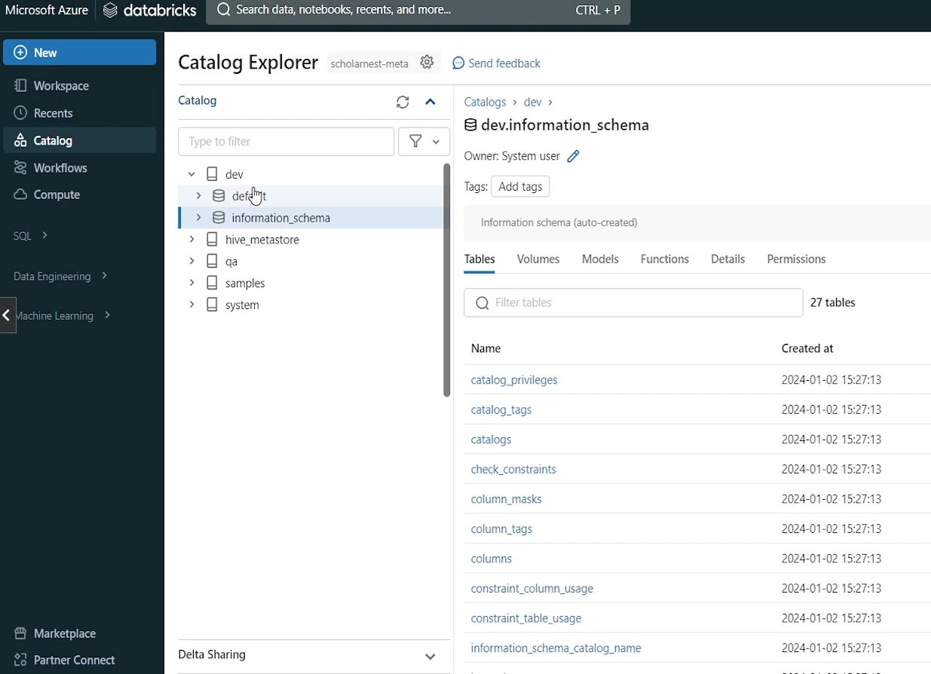

|  |  |
| --- | --- |
|  | Similarly in the QA catalog you can see default and information schema. You should leave the information schema as it is.  But you can drop the default database if you want. So. But before dropping that, let's see how do we create a new database in one of my catalogs. So for example, I want to create a demo DB database in my dev catalog. How to do it. You already know the syntax how to create a database right? So let's do create. Database. If not exist. What is the database name? Demo DB so let's give a database name as demo db. |

But now we implemented Unity Catalog and we also created catalog. We created dev catalog and QA catalog. So whenever I'm creating a database I should decide in which catalog I am creating this database. Is it for demo dev environment or it is for dev catalog or it is for QA. So I want to create it for dev. So we should prefix the catalog name before the database name. It is same like when you create a table in a database, you prefix the database name before the table name, right? Same way, once you have the unity catalog with every object you will use. Catalog name prefixed before the database name. So for example, if I have a table called people table in Demodb database. So how do I refer people table dev dot demo db db dot people. So every object should be referred with three levels of naming. First should be catalog name, second should be database. And then you can have table or view. So let's create this database and see. Done.

|  |  |
| --- | --- |
|  | If you come to Catalog Explorer in the dev. Database in the dev catalog. Let's refresh it. You can see now a demo DB database. So we created a demo DB database inside it. you can even drop, your default database from the catalog if you want to. So here is an example that we want to drop default database from the QA catalog. So how to do it. You already know how to drop objects right. So drop database if exists. And what is the database name that we want to drop. We want to drop the default database from QA catalog. So it's QA dot. Default, right. And we already have a default database here in the QA. So let me drop it and we can verify it from here. Right. This default database. Refresh it and it's gone. |

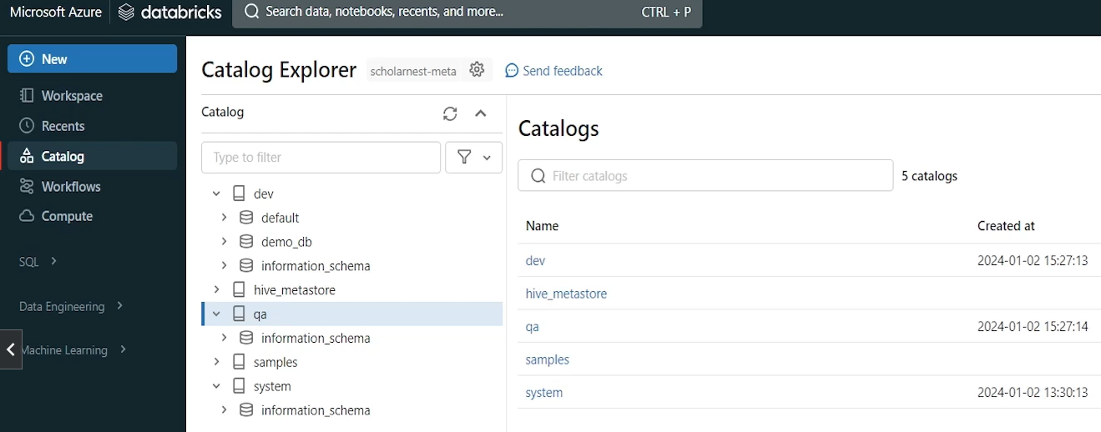

So idea is you have option to create catalog objects or unity catalog objects from the code like this. You can create databases tables you can drop. Or you can also use UI to do the same thing. For example, if in the QA catalog, if I want to create a schema, I have this button here, right? I can create a database here. Even if you come to the catalogs, you have a button to create catalog. So everything that you want to do with the unity catalog can be done from the UI. Also, it's very good, simple, easy to use UI, but you can do it from the code. Also, you can script things and you can automate things. So now we learned how to create objects. Same way if you know SQL or DDL statements for creating tables, creating views, creating other type of objects like user defined functions, you can create all those things.

Next most important part of Unity catalog is to manage privileges. So let's, start learning how to grant privileges to different kind of objects in unity catalog. So we want to do a simple example here. we want to grant use catalog privilege on the dev catalog. So how to do it? Let's, do that. We can use, grant command to grant the privilege. And similarly, we have a revoke command for revoking the privilege. So. Grant. And then we tell what is the privilege that we want to grant. So we want to grant use catalog privilege. So that's the next thing grant use catalog. And then on what? So on and on what dev what is dev. Dev is a catalog. So on Catalog dev.

|  |  |
| --- | --- |
|  | So grant use catalog on catalog dev. And then to whom, whom do we want to grant this. So we want to grant this to scholar-nest-dev Group. Dev group, but that's a user group, so it must be enclosed in a backtick. a pair of backticks. So don't forget that. Otherwise, you might see an error. So we wanted to grant use catalog privilege on catalog dev to is called as dev. And it's so easy. let's do one more example. We want to grant all privileges on Demodb database, so let's do that. Grant. what is the permission that we want to grant all privileges on. On what? On data. Base right on data base. |

And what is the database demo DB. So demo db database. But I have to prefix the. Catalog name also. So catalog name is dev. I created Demodb database in dev catalog and two to home to same group.

|  |  |
| --- | --- |
|  | So let's do this same group right. So we want to grant permissions to this group on these two objects dev and demo db. But before that let's go and look at the Catalog Explorer. Right. So in the demo DB. In the dev demo. DB you can see permissions here. So as of now there is no permissions I have. you I also I can use this grant button and grant permissions using UI. so you can do it from here. or you can do it from the code. So let me run this code. |

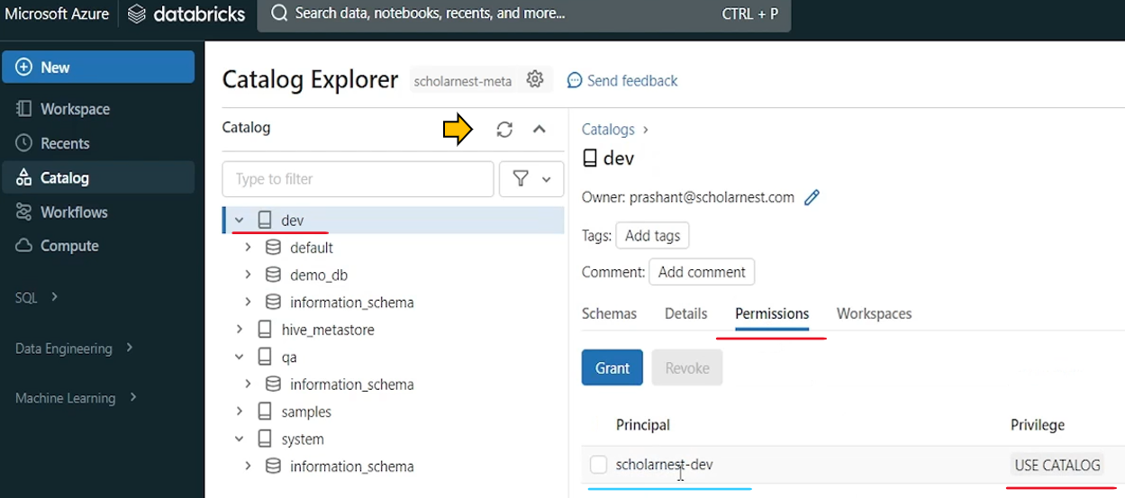

I can see like, okay, here you come here. refresh this. Maybe here. And in the demo DB permissions you can see is colonist. Dev has got all privileges. And on the catalog permissions is colonist. Dev has got used catalog privileges. So if you want to revoke it you can select it and use the revoke button. Similarly on the demo DB database come to permissions. Select this permission. You want to revoke it. You can use this revoke button. And you can revoke it. You can use it at Catalog Explorer.

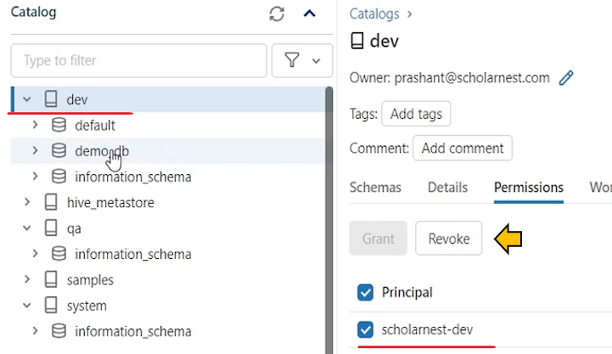 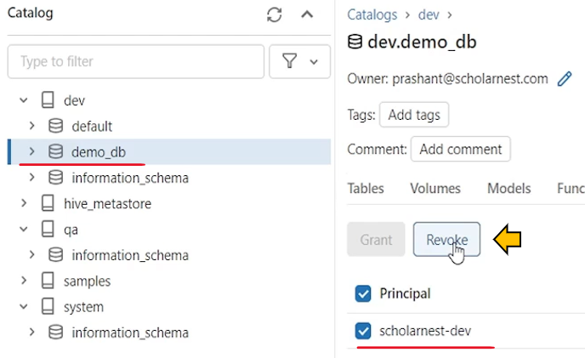

Or you can write code for doing all that. Similarly, like you are using grant command, you can use the revoke command.

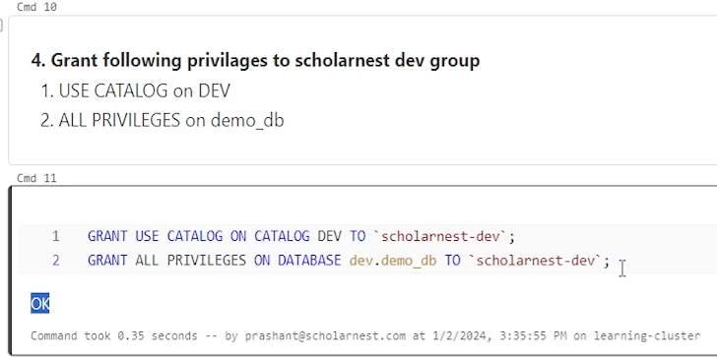

Now we'll learn to create dev catalog. We learn to create date base in the catalog. And we also learned how to give privileges, on the catalog or on the database. And now we need to learn few things on database objects, like how do we create tables, how do we create views, how do we create volumes. So I'm assuming that you have already worked with the spark SQL. You know DDL statements for creating tables. So it's simple create table and then you give the details and you can create a table similarly view. Also you can create volume is little new. So let's see how we can create a volume. So create a volume under demo DB database.

|  |  |
| --- | --- |
|  | And what is volume. We already learned. Volume is a storage volume where you can store data files. You can create subdirectories also and store data files in your subdirectories inside the volume. So how to create a volume. It's simple. We have, create. Volume statement, create volume, and then, let's, give the details. We want to create it inside the dev catalog, inside the demo DB and then volume name, let's call it files. Right. That's the volume we want to create. Put a semicolon. If you are writing multiple lines in the same cell, semicolon is mandatory. Otherwise it's optional. So let me run it. Ah. It's done. You can come from here. in the demo DB maybe you can see a files volume here. |

You can see visually, what are the files here? But we don't have anything here, so we cannot see anything here, upload a data file to your volume. So if you want, you can upload data files to this volume from here. Upload to this volume, maybe in the notebook.

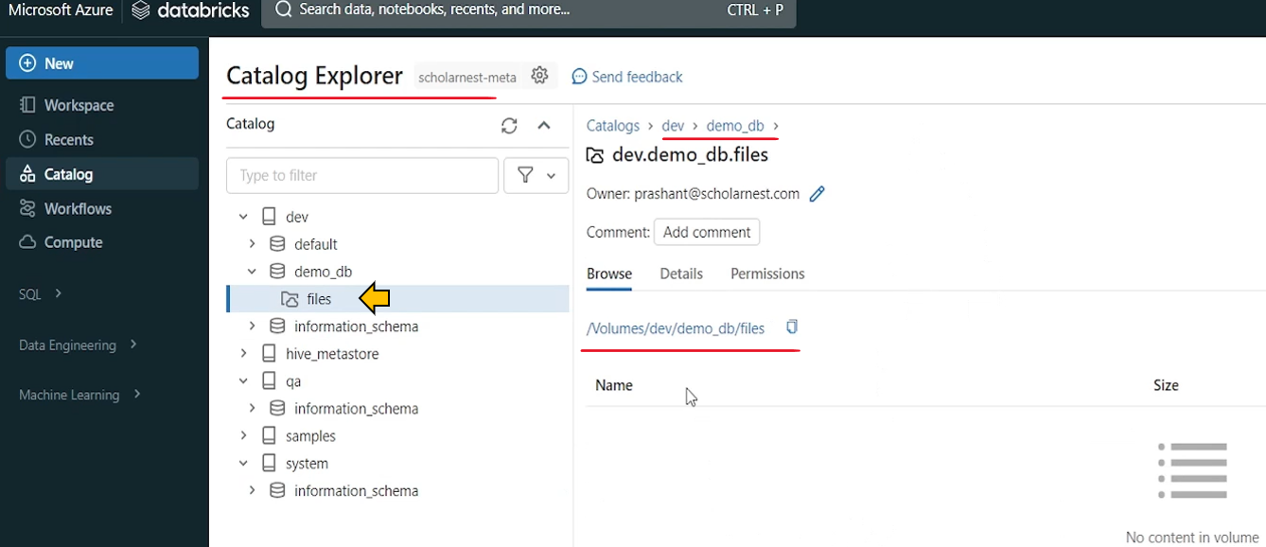

Also, upload files to volume preview mode. So you have a shortcut option here. So uploading file to your volume, is something that you will be doing through the UI itself. So let's come here and upload to this volume.

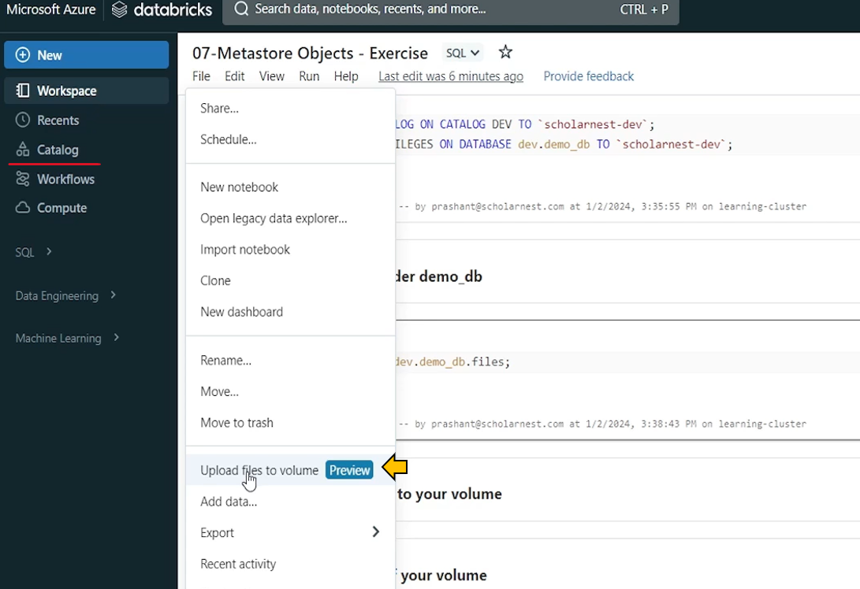

And it goes into the volumes dev demo DB files. And remember this naming. Every volume can be referred with this location, this kind of location where slash volumes is fixed. That's a fixed, directory location, which is always prefixed with all volumes. And after that your volume is created inside the database. So you will have data catalog name / database name / volume names. And your files will sit here. So that's how you can refer to your volume from code if you want to refer it from the code, this is the directory location. Let me copy it so we can, show you a demo. You can browse, and select your data files or drag and drop, I have selected one, people.json and let's upload it.

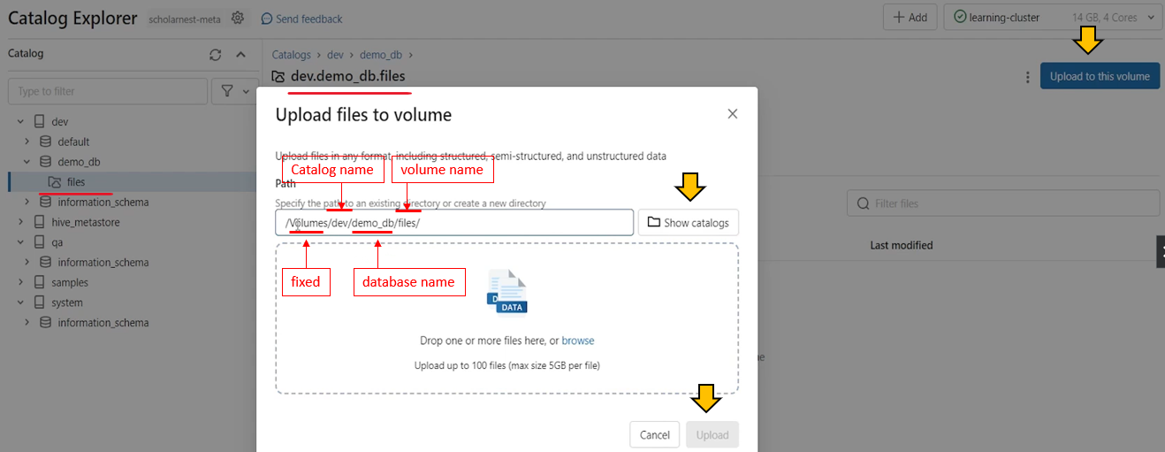

My file is now in the volume, right? So I uploaded my data file into the volume. let's come here, upload data file into the volume. And if you want to list the content of the volume, you can use percent FS magic co and LZ. And we already learned how to refer the volume. So it should be volumes. Then your catalog name database name and then files. And you can refer the volume. So let's do the ls from here percent fs ls. And I can see people.json is here.

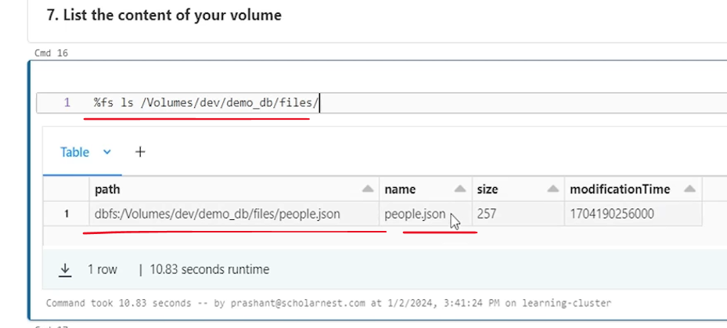

So basically it is in the Dbfs route in the Dbfs route. Databricks automatically created a volumes directory and all this goes into that volume. . Um. You can check it out from the Catalog Explorer UI, which is here. Right. And but on the volumes, you can grant permissions. So I have already granted permission here is called as dev all privileges to the volume. actually, I gave all privileges on the demo DB database here. This is what we did, a few minutes ago. And in unity catalog, those privileges are inherited. So if I give all privileges to the demo DB database, all the objects inside the demo DB database will automatically inherit that, privilege. So, I gave all privileges to Scott Ernest Dev at the database level. So volume is inside the database. So already I have this permissions.

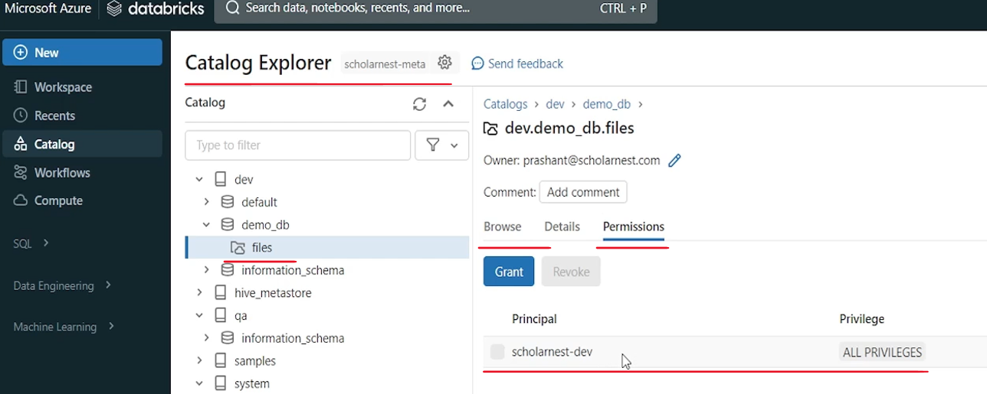

But the point is you can create volumes and you can grant permissions to your users whether they can access the volume, they can access files in the volume or they have read only access or you they have read write privilege all that you can manage. And accordingly, people will have restricted privileges. or you can do fine grained, privilege management on the directories also. So that's done. now next thing is, other than volume, there is an, new type of object that Unity Catalog supports, which is known as external locations or simply, locations. So how do we create external locations? So let's use Catalog Explorer for now for creating an external location. And we will learn how to create it using code. sometime later. So external location is, like your dbfs mounts, right? what we do, we create an external location, map it to some your Azure ADLs storage container, and then you can access data if it is already available on that container, you can access those files, from within database. But the beauty is that once you create an external location, you can provide privileges on that. You can manage permissions on that external location from the unity catalog. We couldn't do that on the dbfs mount point. So for, creating external locations using the Catalog Explorer UI, you can come here. you can see external data tab here.

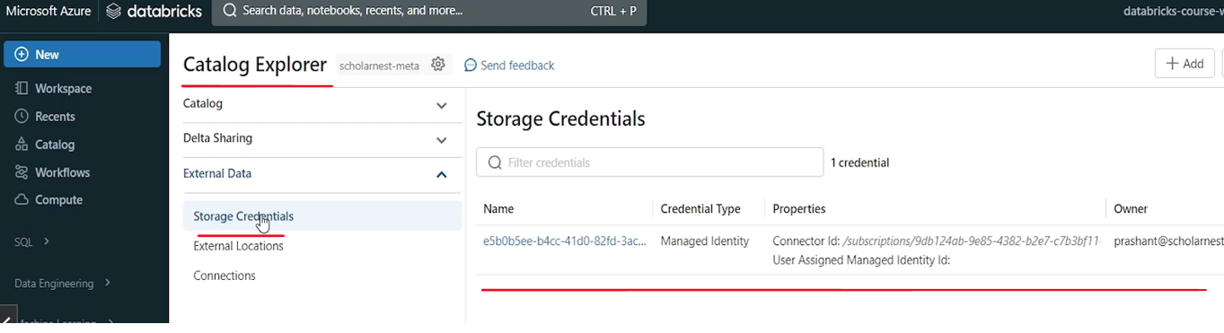

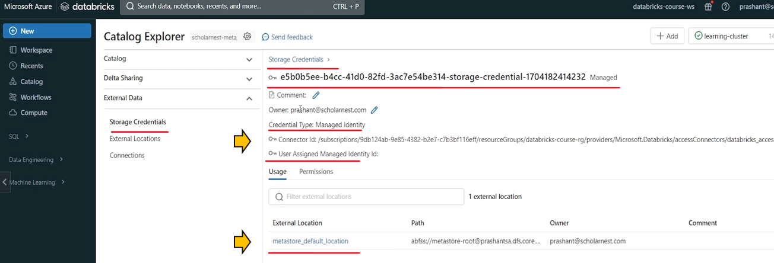

And in that external data, you should have at least one storage credential, which will have access to your container once you create a unity catalog, once you do the unity catalog setup, you will always have at least one storage credential. So this storage credential we created earlier, which is the connector that we created. Right. So for that connector we created storage credentials. So this is your storage credential. And it is a managed identity. And it points to meta store default location. Right. And you can give permissions on this, so you can give permissions to your dev group on this storage credential.

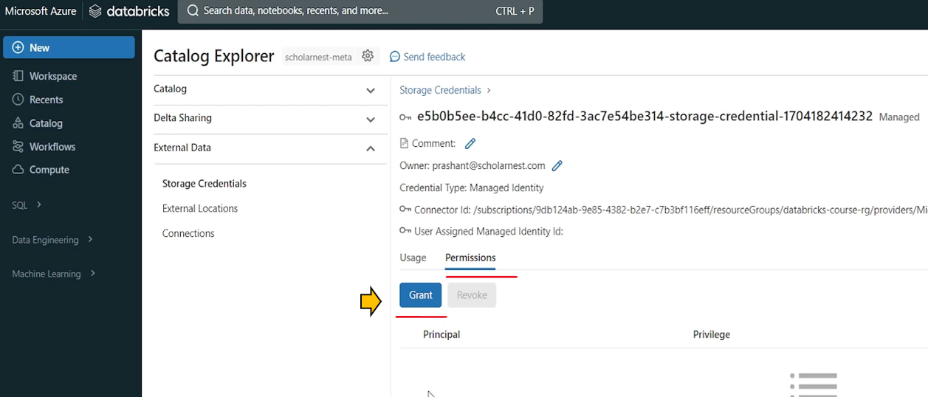

But we don't want to do that. The point is, I wanted to tell you that, you should have at least one storage credential which can be used to access your cloud container. So that you can create a external location from the unity catalog. So we already have a storage credential here. I can simply come to the external locations and create a external location. In fact, there is one location already created here which is used by the meta store, unity catalog, meta store. We do not want to disturb that. We want to create a new location. So let's create a new location. let's call it, external-data. The storage credential we want to use is the existing one. So we already have one. If it is not there we can create a new one. But we already have one. And what is the URL. So URL is your. abfs:// file system for Azure Cloud Storage/ container name / storage account name dot rest of the things. So let me paste the, code here.

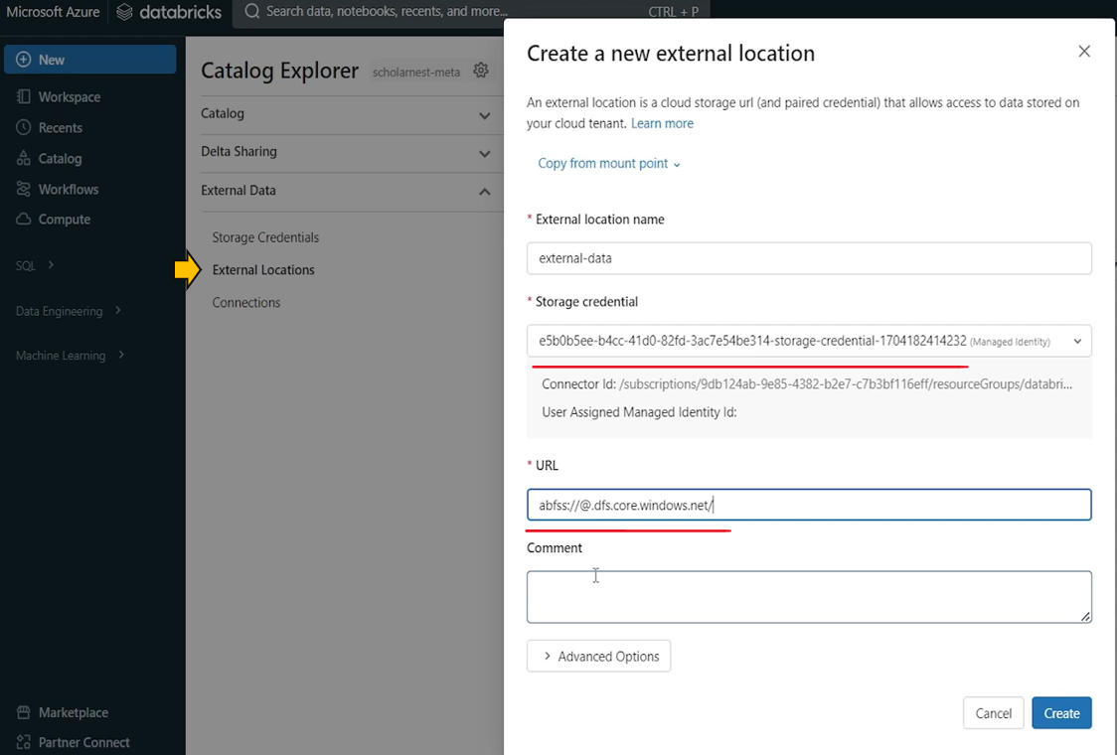

So URL. Looks like this. It should be a BFS colon slash slash. And then you should provide your container name. So what is my container which I want to map here. Let me go to my Azure portal and see what containers do we have. I'll come to my storage account. And come to containers. We have this dbfs container, which we were, mounting earlier.

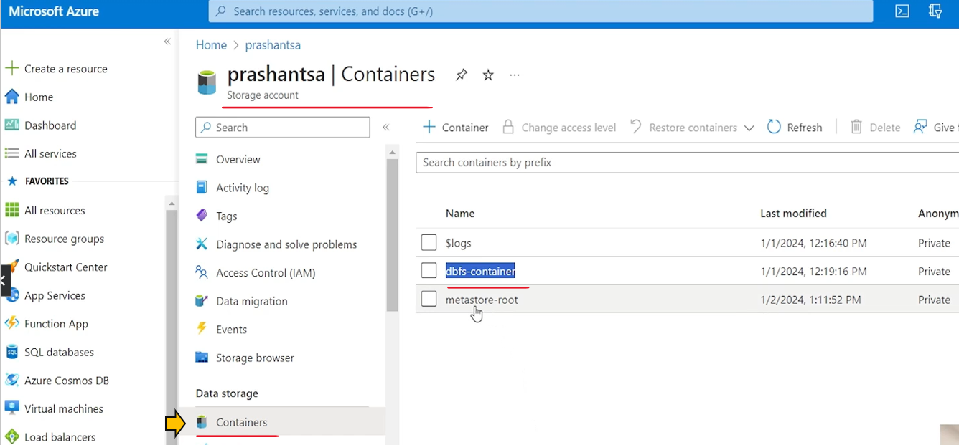

And we have this metastore root container, which I was, um. Using for unity catalog route storage. So this one we don't want to touch. I want to leave this for Unity catalog and this Dbfs container. I tried to mount it, but we know mounting is, not reco ended. So let's create an external location for the same container. So. We come here? copy the container name and account name. So account name is storage account name. Storage account name is prashantsa.

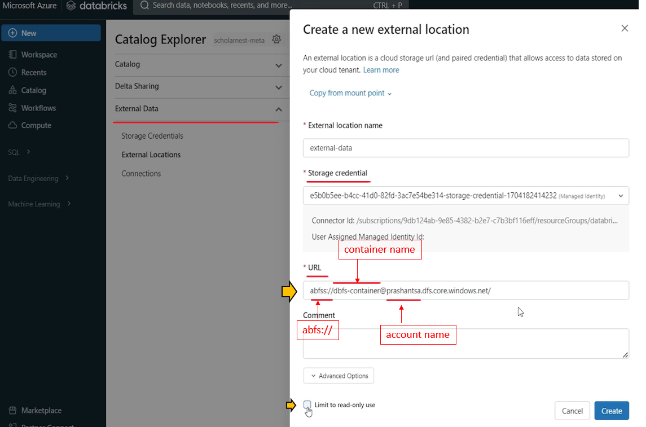

And that's all, if you want to make it, read only for everyone, you can make it, but we don't want to do that, so that's all. Hit the create button, and your external location is created. Come back to here and you will see you have an external data external location.

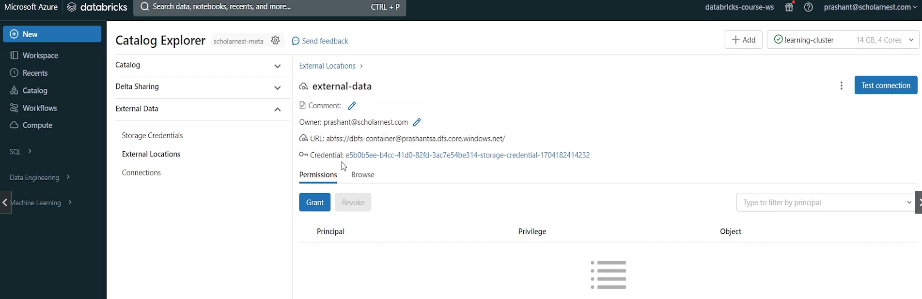

So we created external location.

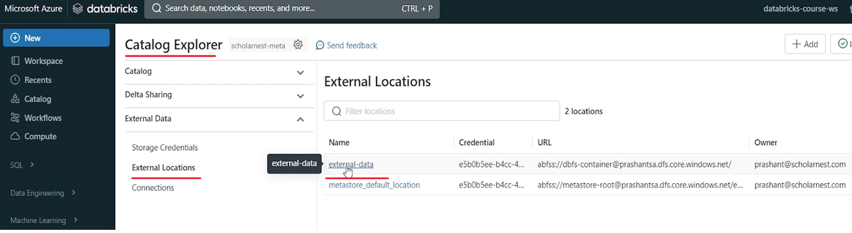

You can grant permissions on this external location, or you can browse what we have in the external location. So in that container we know we created a sample data directory and uploaded Json file earlier. So I can see that here.

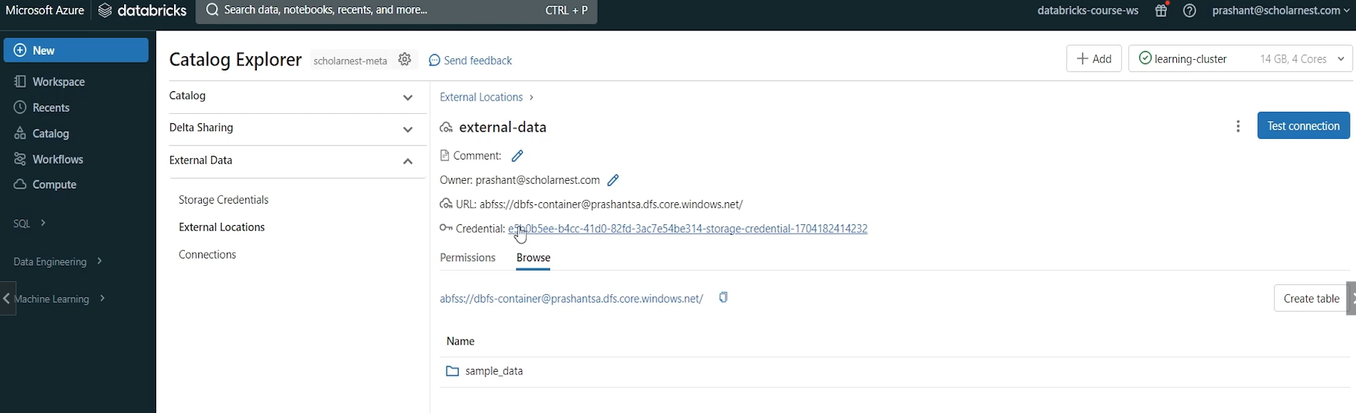

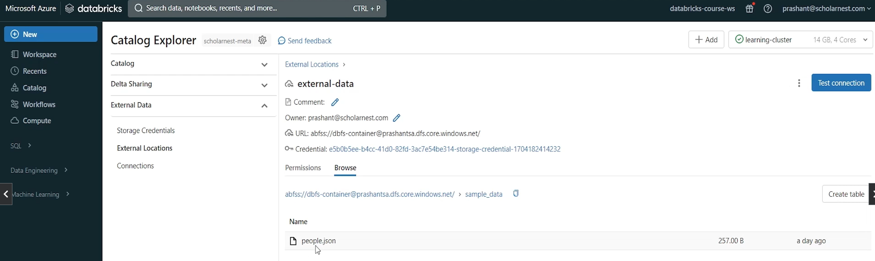

So you can see that from here also right in the sample data Json file. So whatever is already there in your container will be available under your external location. So that's the idea behind the external location.

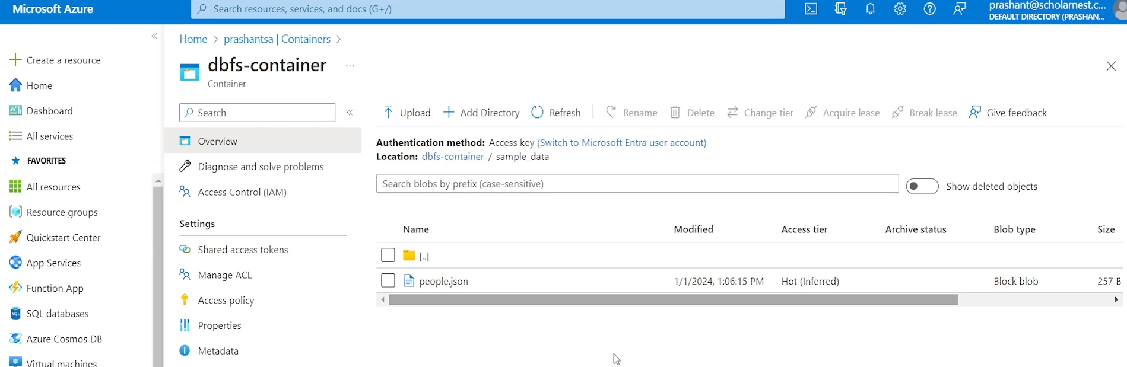

If you already have data in some cloud directory, create an external location, pointing to that directory and start using it in your, Databricks project. So we are done with the external location creation. Now create an external location to an existing container or directory in ADLs and use the Catalog Explorer for doing that.



So we have done that. Now can we describe that external location from code. So you can definitely describe what is the co and. Same describe right. Describe, what do you want to describe? External location. And what is the external location name? let's copy it from here. You should know the external location name. Right? So this is the external location name, but names must be enclosed with a Backtick . Whether it is user, group name or external location name, you should. to avoid unnecessary errors, you should, be in the habit of enclosing into the, pair of backticks. So let's run it and you can see what is the name of the external location, what URL does it point to? It points to the Azure, cloud File System. Dbfs container at this storage location. And this is for the Microsoft Cloud, which credential it is using, right. Which is storage credential is used to access this directory location. So that's defined here. Who is the owner of this external location. Who created it, what time it is created. If there is any co ent all that you can create the external root location.

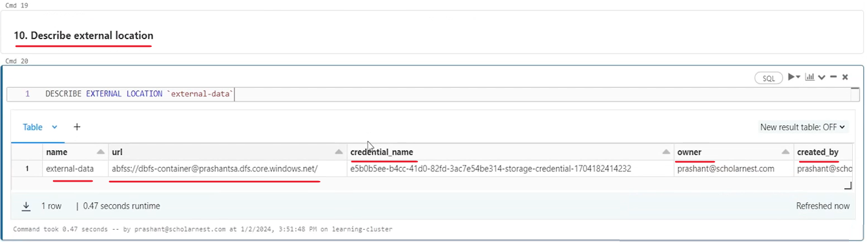

If you want to grant like read files privilege on this external location to scholar-nest-dev, you can do it from Catalog Explorer like you come to external location. Come to this external location from the grant. let's say read files this permission and to home search for the group is called as group or any of the existing users.

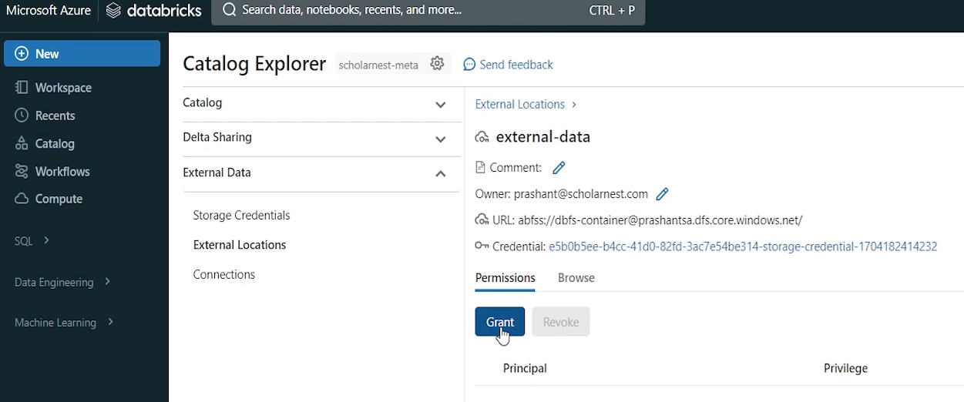

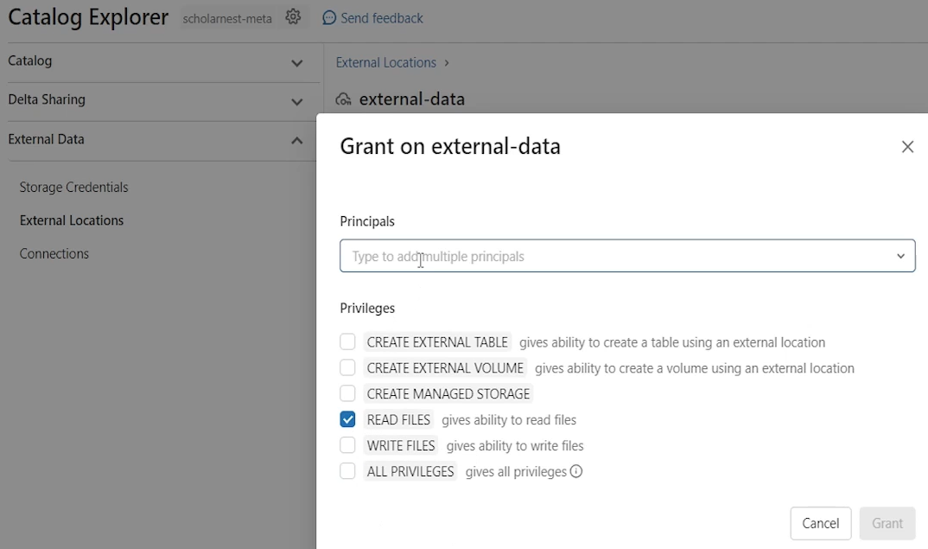

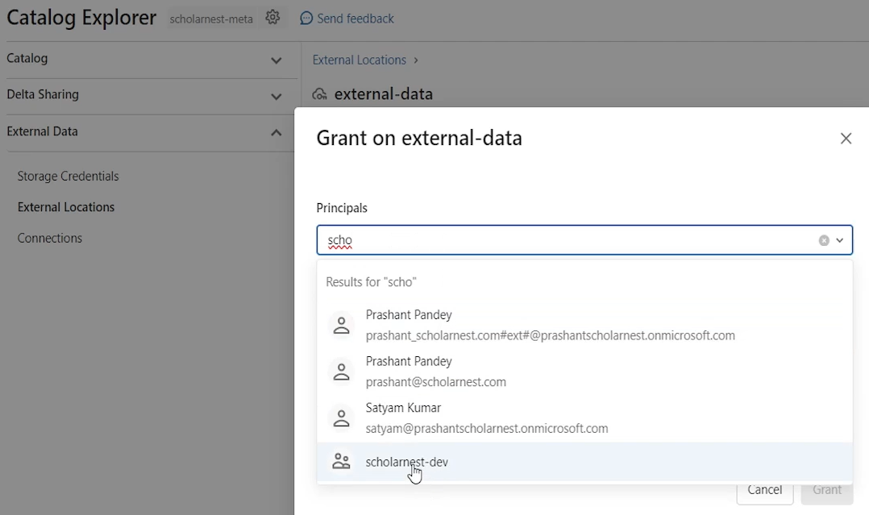

All users are that we imported in our unity catalog will be visible here. We want to grant it to scholar-nest-dev user group. And you can hit the grant button, from here. And you can grant this permission from the UI. but we want to grant it from the code. So how to grant it? Grant and what permission we want to grant. We want to grant. Read files. Permission. on. On what? On external location. And what is the external location name? let's copy it from here. This is the external location name and grant it to home is called as dev. Let me copy it from maybe here. Tally. Two this and let's run it.

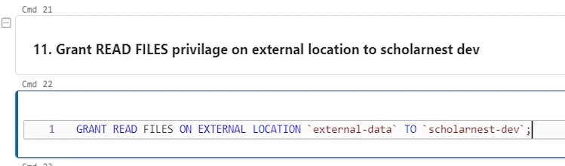

Done. So if you come here. you will see the grant is already added here. If you want to revoke, hit that button or, revoke it. So that's how we. Um. Can. Create a external location using the UI. We will learn how to create it using the code. You can describe. You can, grant privileges to on the external location. if you want to access the external location from your code, you have to use this URL, right? You cannot access it from the name.

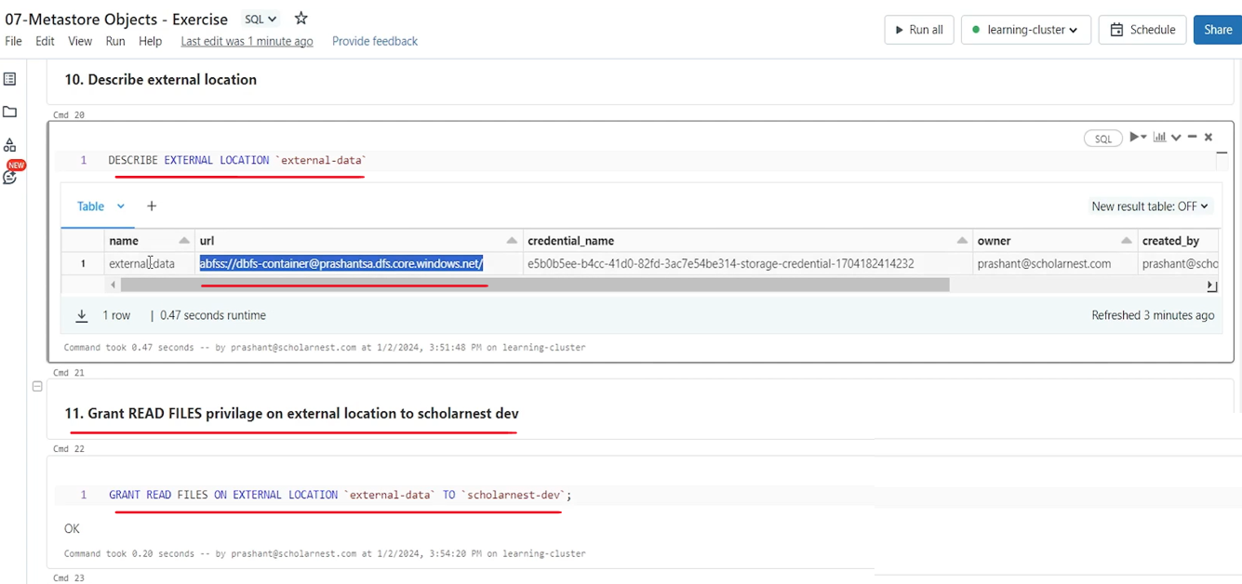

it's not that easy. but, for example, list the content of external location. So percent FS, you can use LHS and use the external location URL. Right. You can use this URL if you have not created any external location with proper credential to this URL, you cannot directly do the fs ls magic command. It won't work.

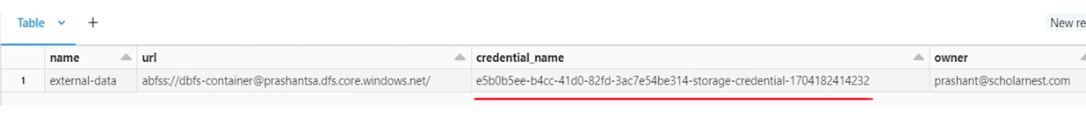

But since you have already created a external location for this URL, external location name is this and there is a credential already mapped with this URL which allows, Databricks Unity Catalog to access this, location. And that's why Fsls will work. And we already learned that Fsls, allows you to access different kind of file systems, right. with appropriate file qualifiers. So I am using a BFS that's a qualifier for Azure Data Lake Storage. And we can access the root directory of this external location directly. So we have a sample data directory inside.

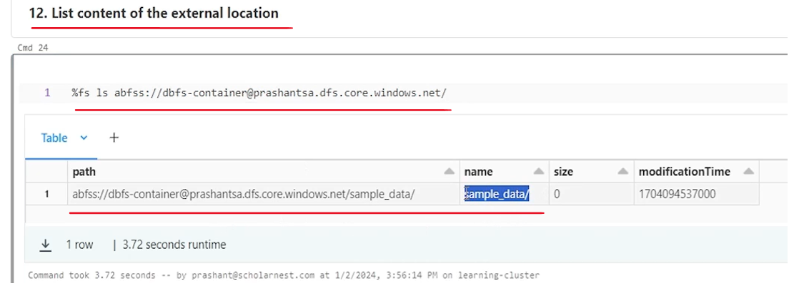

You want to navigate inside the sample data directory. You can do that. And you can see the people dot Json file. So that's how you can access, external location or data inside your external location. You can even use this URL, in your. Data frame APIs for reading data from this directory. So that's all.

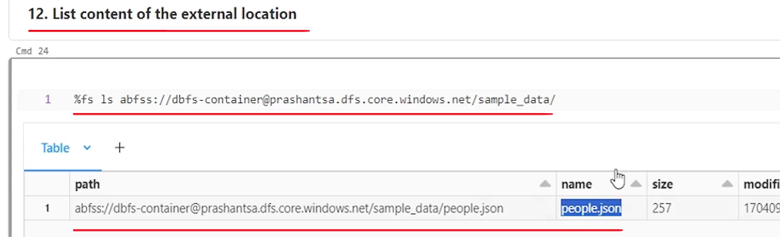

So I think that's all I wanted to give you a demo for. You might have got, good sense of how to create objects inside the unity catalog, how to create external location, how to create volumes, and how to grant different kind of privileges. Now, I help you to refer to the documentation for details of what all privileges are available on different types of Unity catalog object. So the topmost object is meta store itself that we created, from the Databricks account console. And then inside the meta decks. meta store we can create catalog. And then in inside catalog we can create schema, which is database. And inside database you can have tables, views, volumes and things like that. if you scroll up in this document, you will see that the hierarchy, this is how the hierarchy is. Meta store inside meta store you have catalog. Inside catalog you have schema. And inside schema you can create all these things. external location is not inside schema. It's outside. Similar. Similarly storage credential is also outside.

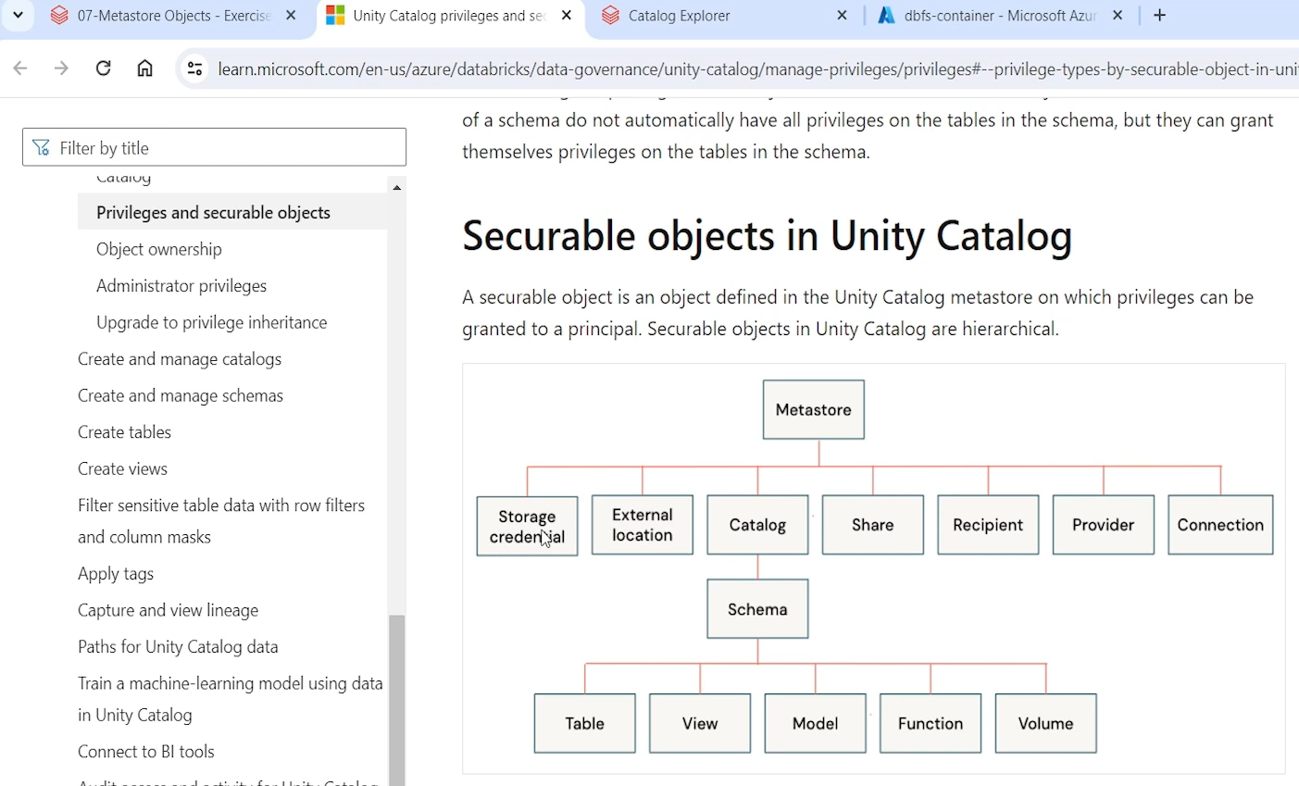

So you can create all these things and you can get the list of allowed privileges for each type of object. So on the catalog you have all privileges.

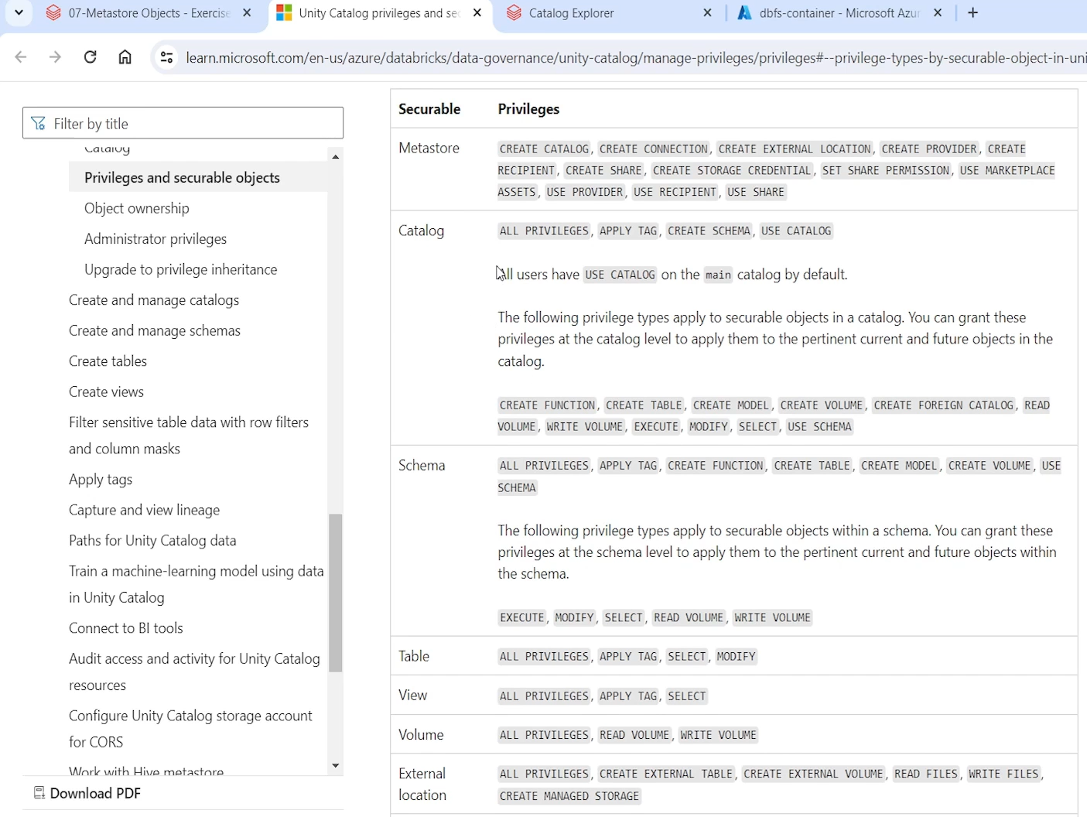

Maybe create a schema and use catalog. These three are most important ones. and then other privileges are also there.

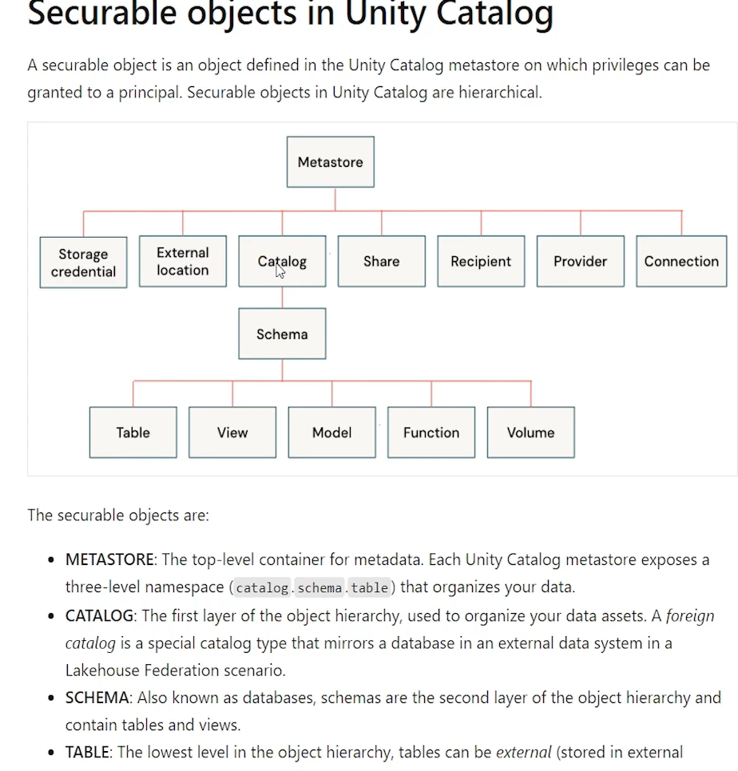

And the idea is that. In unity catalog, you have to understand that privileges are inherited. So if you grant some privilege at the catalog level, they are inherited on all the objects in the. A schema. So in suppose in the dev catalog, you, assigned all privileges to someone. Then in the dev catalog. Whatever database. Let's say you are creating three databases bronze, silver, gold on all three databases, on all the objects inside those databases, that user has got all privileges because you gave him all privileges at the catalog level. Similarly, if you gave him all privileges at the database level, all the objects in that database will inherit those privileges.

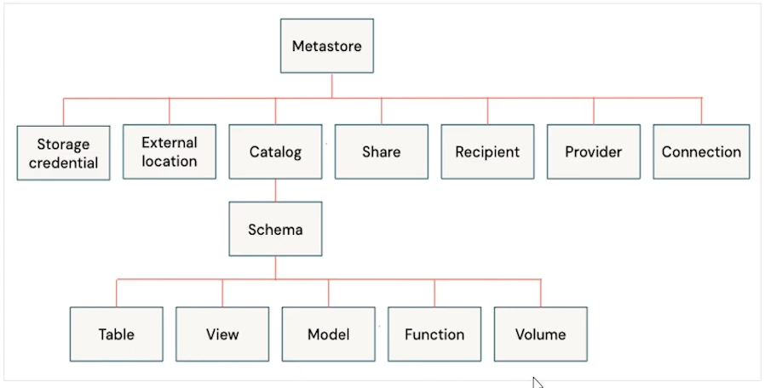

So be careful while assigning privileges, it is easy to assign privilege at the higher level and get it inherited automatically, under that object. but it's dangerous also if you don't want that to happen. So what all privileges do we have? All privileges. And then maybe in the schema you have all these privileges at the table level, you have all privileges. Select and modify privileges apply tag is also a privilege. but these are the most important ones.

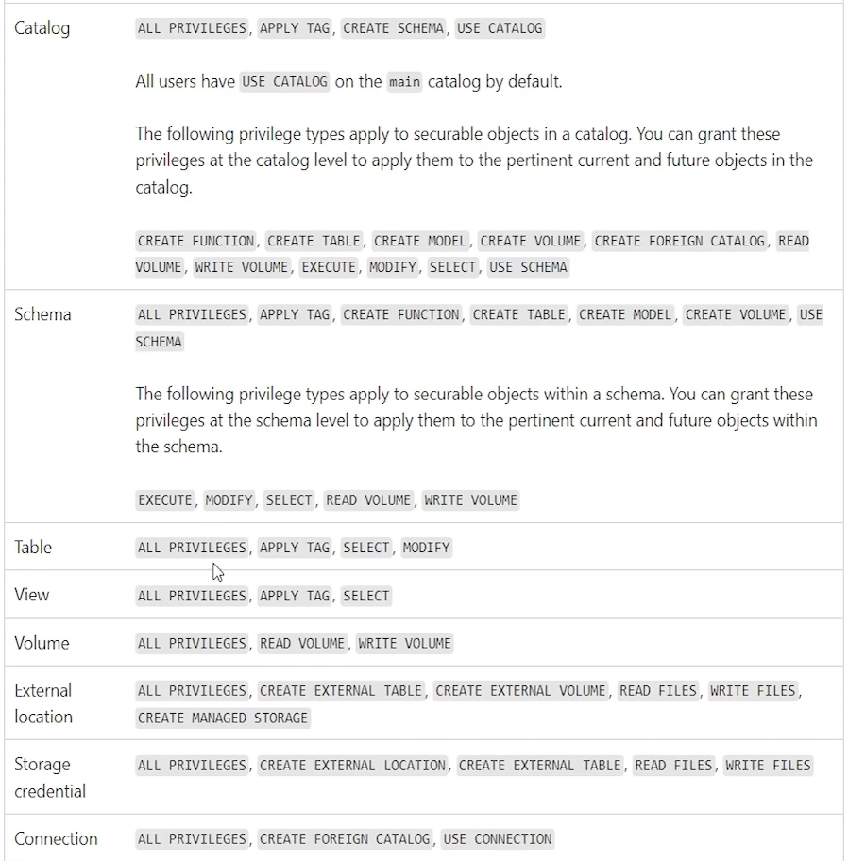

Select and modify on the volume you have read. Volume write volume privilege. Write on the external location. You have all privileges. You have create external table privilege. Because if you already have data on some external location, you might want to create an external table on that. You can even create external volume. You can grant read files. Write files. We create managed storage. So all. Those different types of privileges. You can. Grant. So that's all for this, lecture. I hope you understand. Now, what is Unity Catalog, how we build the storage layer for our, lake house projects? And how do we manage, different types of objects, metadata, users and privileges, for our project using the unity catalog.